TITLE (upper case, max. two lines)

First Author⁽¹⁾, Second Author⁽²⁾, … (first and last name of each author, separated by commas)

⁽¹⁾ Position, affiliation, e-mail address
⁽²⁾ Position, affiliation, e-mail address
…

Abstract
The abstract needs to be the same as the one given in the accepted version. Adjustments are allowed only when needed to take into account reviewers’ suggestions. The abstract should summarize the context, content and conclusions of the paper in 250 to 300 words. It should not indicate how the paper is organized. It should not be a table of contents in prose, or an introduction. It should not contain any references or equations. Typeset the abstract in 10pt Times New Roman with exact line spacing of 11pt.
Keywords: keywords1, keywords2, etc. Authors should suggest approximately 4–8 keywords for indexing purposes (separated by commas). Keywords should be italicized and the Times New Roman 10 pt. font should be used.

1. General Appearance
This document explains and exemplifies how to prepare papers for the 1st Croatian Conference on Earthquake Engineering – 1CroCEE 2021. Papers should not exceed 8 pages in length including the abstract, figures, tables, endnotes, and references. The minimum number of pages is 4. Manuscripts need to be written in English language. Authors are required to submit their manuscripts in MS-WORD format only (.doc or .docx), and should check their formatting (as per guidelines below) before submission.

2. Organization
Following the abstract, it is suggested to start with an Introduction section and end with a Conclusion section summarizing the main findings of the paper. All sections should be written and arranged in a style that is succinct and easy to follow. The text should be single-spaced and 11pt Times New Roman font should be used. The entire text must be in a single column format. Please indent the second and the following paragraphs by 1 cm.
Section headings must be written in bold upper/lower case letters, as shown above, and in size 13. Subsection headings must be written in bold and in size 11. Do not number the pages.
All Tables, Figures and Equations used in the text should be numbered in sequence. Please pay attention to the quality of Figures.

2.1 Numbering of subsections
Use the decimal system of headings with no more than three levels.
2.2 Tables and Figures
Tables must be referred to in the text as follows: Table 1, Table 2, ... . Tables must be submitted as part of the text, as shown below. The caption of each table must be placed above the table, centred and 10pt font size should be used. We suggest 10pt font size for table content also, but not smaller than 8pt.
Table 1 – Dynamical properties of model
Mode | T (s) | Mx | My | MRz
1 | 0,116 | 0 | 0,833 | 0
2 | 0,087 | 0,755 | 0 | 0,076
3 | 0,062 | 0,076 | 0 | 0,755
4 | 0,029 | 0 | 0,167 | 0
5 | 0,021 | 0,153 | 0 | 0,016
6 | 0,015 | 0,016 | 0 | 0,154

Figures must be referred to in the text as follows: Fig1, Fig.2, ... . Figures must also be submitted as part of the text. Colour Figures can be used, with a minimum resolution of 300 dpi. The caption must be independent of the corresponding figure and placed below the figure. Figures should be centred and attention should be paid that the Figure is aligned “in line with text” using Format Object Toolbar, Layout tag.
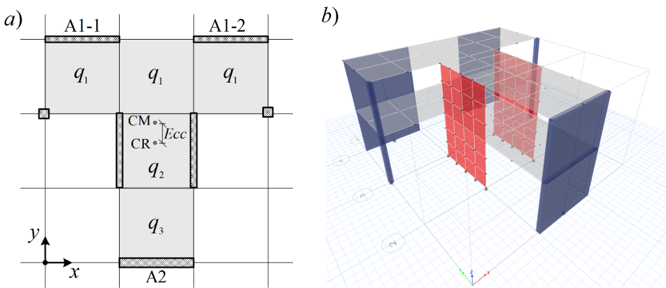
Figure 1. a) Building plan; b) Numerical model.

3. Equations
Symbols denoting vectors and matrices should be indicated in bold type. Scalar variable names should normally be expressed using italics. Weights and measures should be expressed in SI units. Equation numbers must be right aligned and placed in parentheses, not including the abbreviation Eq., as shown in Eq. (1) below. In MathType or Microsoft Equation please set the font size to 11pt and for Word Equation Editor please set the font size to 10pt. In MathType or Microsoft Equations select the MathType menu “Size” > “Define”. When the “Define Sizes” dialog appears, set the value for “Full” to 11pt. Equations should be referred to within the body text in abbreviated form, e.g., Eq. (1) or Eq. (2). Equations are to be centred on the page and 8pts of empty space should be left above and below the equations. Displayed equations should be numbered consecutively in the paper. Conventional symbols should be adopted and used consistently.
An equation made using Word Equation Editor should appear as
$a^{2}+b^{2}=c^{2}$ (1)

An equation made using MathType or Microsoft Equation should appear as
(2)

4. Acknowledgements
Acknowledgements provide an opportunity to express appreciation to those who contributed significantly to the preparation of the paper. They may be written in free style, and must be brief.

5. Copyrights
1CroCEE 2021 reserves the copyright on the published proceedings. Authors will have the right to use the content of published papers, in part or in full, for their own work. Authors who use previously published data and illustrations must acknowledge the original source in the accompanying captions.

6. References
References must be cited in the text using square brackets [1, 2], numbered according to the order in which they appear in the text, and listed at the end of the manuscript in a section called References, in the format showed below.

For journals:
- D’Ayala, D., Speranzaa, E. (2003): Definition of Collapse Mechanisms and Seismic Vulnerability of Historic Masonry Buildings. Earthquake Spectra, 19 (3), 479–509, doi: https://doi.org/10.1193/1.1599896
- Bommer, J., J., Stafford, P., J., Akkar, S. (2010): Current empirical ground-motion prediction equations for Europe and their application to Eurocode 8, Bulletin of Earthquake Engineering, 8, 5-26, doi: https://doi.org/10.1007/s10518-009-9122-9
For published conference proceedings:
- Magenes, G., Penna, A. (2011): Seismic design and assessment of masonry buildings in Europe: Recent research and code development issues, 9th Australasian Masonry Conference 9AMC, Queenstown, New Zeland, 21 pages.
For project technical papers and design provisions:
- POLIMI (2010): Critical review of methodologies and tools for assessment of failure mechanisms and interventions, Deliverable 3.3, NIKER Project, Italy.
- Kayen R, Carkin BD, Corbet S, Pinilla C, Ng A, Gorbis E, Truong C (2014): Seismic velocity site characterization of thirty-one Chilean seismometer stations by spectral analysis of surface wave dispersion. Technical Report PEER 2014/05, Pacific Earthquake Engineering Research, Berkeley, USA.
For books:
- Chopra, A. K. (2019): Dynamic of structures. Pearson Education, 5th edition, United States.
For electronic sources:
- Beyer, K., Wilding, B., Rezaie, A.: Drift capacity models for modern URM walls for EC8 Part 1, Earthquake Engineering and Structural Dynamics, Laboratory, Ecole Polytechnique Fédérale de Lausanne, Switzerland, https://eesd.epfl.ch/, Version: 10.1.2019, https://zenodo.org/record/2536830#.X8Pxac6g9PZ, (accessed 29th November 2020).
For personal communication:
- Lazarevic, D. (2019). Personal correspondence.

