TITLE (uppercase, max. two lines)

First Author ⁽¹⁾, Second Author ⁽²⁾, … (first and last name of each author, separated by commas)

⁽¹⁾ Position, affiliation, e-mail address
⁽²⁾ Position, affiliation, e-mail address

Keywords: keywords1, keywords2, etc. Authors should suggest about 4–8 keywords for indexing purposes (separated by commas). Keywords should be italicized and Times New Roman 10pt font should be used.
This document explains and illustrates how to prepare an extended abstract for the 2nd Croatian Conference on Earthquake Engineering – 2CroCEE 2022. Extended abstract can only be submitted for the Engineering Seismology session and PhD special session.
Papers should not exceed 2 pages in length with 500 to 1000 words. It may include figures, tables, endnotes, acknowledgements, and references. Manuscripts must be written in English. Authors are required to submit their manuscripts in MS-WORD format only (.doc or .docx) and should check their formatting (according to the guidelines below) before submission.

1. Organization
The text should be single-spaced and 11pt Times New Roman font should be used. All text must be in a single column format. Please indent the second and the following paragraphs by 1 cm.
Section headings must be written in bold uppercase/lowercase letters, as shown above, and in size 13pt. Subsection headings must be written in bold and in size 11pt. Do not number the pages.
All tables, figures and equations used in the text should be numbered in sequence. Please pay attention to the quality of the figures.

1.1 Tables and Figures
Tables must be referred to in the text as follows: Table 1, Table 2, etc. Tables must be submitted as part of the text, as shown below. The caption of each table must be placed above the table, centred and 10pt font size should be used. We suggest 10pt font size for table content also, but not smaller than 8pt.
Table 1 – Dynamical properties of model
Mode | T (s) | Mx | My | MRz
1 | 0,116 | 0 | 0,833 | 0
2 | 0,087 | 0,755 | 0 | 0,076
3 | 0,062 | 0,076 | 0 | 0,755
4 | 0,029 | 0 | 0,167 | 0
5 | 0,021 | 0,153 | 0 | 0,016
6 | 0,015 | 0,016 | 0 | 0,154

Figures must be referred to in the text as follows: Fig. 1, Fig. 2, etc. The figures must also be submitted as part of the text. Colour figures can be used, with a minimum resolution of 300 dpi. The caption must be independent of the corresponding figure and placed below the figure. Figures should be centred and aligned “in line with text” using Picture Format Toolbar, Arrange tab, Wrap Text.
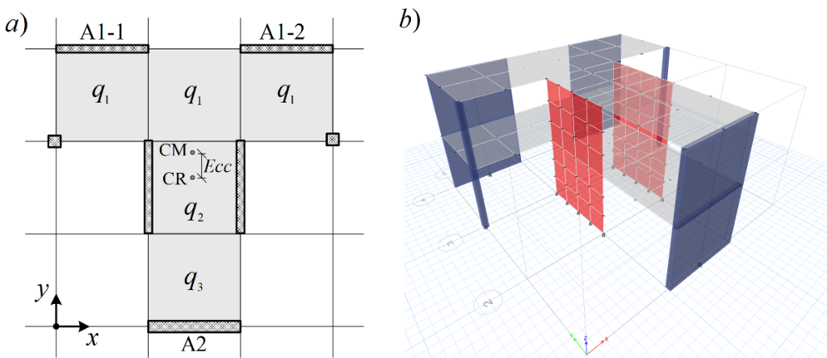
Figure 1. a) Building plan; b) Numerical model.

Symbols denoting vectors and matrices should be indicated in bold type. Scalar variable names should normally be expressed using italics. Weights and measures should be expressed in SI units. Equation numbers must be right aligned and placed in parentheses, not including the abbreviation Eq., as shown in Eq. (1) below. In MathType or Microsoft Equation please set the font size to 11pt and for Word Equation Editor please set the font size to 10pt. In MathType or Microsoft Equations select the MathType menu “Size” > “Define”. When the “Define Sizes” dialog appears, set the value for “Full” to 11pt. Equations should be referred to within the body text in abbreviated form, e.g., Eq. (1) or Eq. (2). Equations are to be centred on the page and 8pts of empty space should be left above and below the equations. Displayed equations should be numbered consecutively in the paper. Conventional symbols should be adopted and used consistently.
An equation made using Word Equation Editor should appear as
$a^{2}+b^{2}=c^{2}$ (1)
An equation made using MathType or Microsoft Equation should appear as
(2)

Acknowledgements
Acknowledgements provide an opportunity to express appreciation to those who contributed significantly to the preparation of the paper. They may be written in free style and must be brief.

Copyrights
2CroCEE 2023 reserves the copyright of the published proceedings. Authors will have the right to use the content of published papers, in part or in full, for their own work. Authors who use previously published data and illustrations must acknowledge the original source in the accompanying captions.

References
References must be cited in the text using square brackets [1, 2], numbered according to the order in which they appear in the text, and listed at the end of the manuscript in a section called References, in the format showed below.
For journals:
- D’Ayala, D., Speranza, E. (2003): Definition of Collapse Mechanisms and Seismic Vulnerability of Historic Masonry Buildings. Earthquake Spectra, 19 (3), 479–509, doi: https://doi.org/10.1193/1.1599896
- Bommer, J.J., Stafford, P.J., Akkar, S. (2010): Current empirical ground-motion prediction equations for Europe and their application to Eurocode 8, Bulletin of Earthquake Engineering, 8, 5-26, doi: https://doi.org/10.1007/s10518-009-9122-9
For published conference proceedings:
- Magenes, G., Penna, A. (2011): Seismic design and assessment of masonry buildings in Europe: Recent research and code development issues, 9th Australasian Masonry Conference 9AMC, Queenstown, New Zealand, 21 pages.
For project technical papers and design provisions:
- POLIMI (2010): Critical review of methodologies and tools for assessment of failure mechanisms and interventions, Deliverable 3.3, NIKER Project, Italy.
- Kayen, R., Carkin, B.D., Corbet, S., Pinilla, C., Ng, A., Gorbis, E., Truong, C. (2014): Seismic velocity site characterization of thirty-one Chilean seismometer stations by spectral analysis of surface wave dispersion. Technical Report PEER 2014/05, Pacific Earthquake Engineering Research Center, Berkeley, USA.
For books:
- Chopra, A.K. (2019): Dynamics of structures. Pearson Education, 5th edition, USA.
For electronic sources:
- Beyer, K., Wilding, B., Rezaie, A.: Drift capacity models for modern URM walls for EC8 Part 1, Earthquake Engineering and Structural Dynamics, Laboratory, Ecole Polytechnique Fédérale de Lausanne, Switzerland, https://eesd.epfl.ch/, Version: 10.1.2019, https://zenodo.org/record/2536830#.X8Pxac6g9PZ, (accessed November 29, 2020).
For personal communication:
- Lazarevic, D. (2019). Personal correspondence.

