THE ROLE OF MILITARY FORCES IN CRISIS - EXAMPLE OF ZAGREB EARTHQUAKE 2020

Marko Šimić⁽¹⁾, Zvonko Sigmund⁽²⁾

⁽¹⁾ lecturer, University of Zagreb Croatian Military Academy, marko.simic2@gmail.com
⁽²⁾ assistant professor, University of Zagreb Faculty of Civil Engineering, Zvonko.sigmund@grad.unizg.hr
…

Abstract
On March 21, the Croatian Government (following a suggestion of the Civil Protection Coordination Center) introduced a “stay at home” order for the whole country due to the pandemic, and the very next day a magnitude 5.5 quake shook the northern part of Croatia, mostly damaging the capital city of Zagreb and its nearest urban satellites, affecting almost 1 million people in total.
Natural disaster situations were not rare in Croatia in the recent years and the main disaster relief role in those crisis situations is assigned to the Civil protection system of the Republic of Croatia. Even though it might not be obvious, military forces play an important role in disaster relief and the Civil protection activities.
In this paper the Croatian national Civil protection system with the rather complex alarming procedure is described. Here the authors place an accent on the involvement of military forces in disaster relief.
Keywords: crisis management, military forces, civil protection, disaster relief.

1. Introduction
In Croatia, the pandemic crisis started on 22nd February 2020. The same day, the Civil Protection Coordination Centre was established by the Croatian Government. It assembled, among others, experts and scientists from the Croatian Institute of Public Health and the University Hospital for Infectious Diseases "Dr. Fran Mihaljević" [1].
The first COVID-19 case in Croatia was identified on 25 February 2020. On March 11th, the county of Istria closed the schools and on March 16th the rest of Croatia did the same, closing schools and universities. All decisions, necessary measures and daily situation updates are coordinated by the Civil Protection Coordination Centre and communicated with the media at least twice a day [1].
On March 21, the Croatian Government (following a suggestion from the Civil Protection Coordination Centre) introduced a “stay at home” order for the whole country due to the pandemic, and the very next day a magnitude 5.5 quake shook the country, mostly damaging the capital city of Zagreb and its nearest urban satellites, affecting almost 1 million people in total.
Zagreb is situated in a seismically prone area. After the big earthquake in 1880 the possibility that the new earthquakes could occur was clear. It was only a matter of time before an earthquake would hit again. The 2020 Zagreb earthquake caused an unprecedented situation - people ran out from their homes, trying to observe social distancing rules, but when you are panicking from a very visible disaster, it is hard to remember and apply rules from another disaster.
This paper shortly presents the role of Croatian Armed Forces in crisis management activities in Croatia. In the paper the examples are based on real occurrences in the recent past of Croatian mainland, while at the same time the authors are critically reviewing the Croatian Civil Protection system.

2. Crisis and crisis management
2.1 Crisis
A catastrophe is a condition caused by a natural or technical-technological event that threatens the health and lives of a large number of people, property of greater value and the environment, and whose occurrence cannot be prevented or eliminated by all operational forces of the civil protection system. regional) self-government in whose territory the event occurred and the consequences of terrorism and war [2]. "Crisis" is an event or situation which endangers the national security, health and life of citizens, significantly impairs the environment or causes significant economic damage, and the response to such an event or situation requires coordinated action by several state bodies and coordinated application of measures within their competence [3].
2.2 Crisis management
Crisis management adopts various measures necessary to manage various forms of crisis. The crisis management process consists of four phases: prevention, preparation, response, and recovery. The way crises are resolved depends on their type, scope and severity. Depending on the type of crisis, different crisis management measures are needed. For each type of crisis or emergency, there are several specific activities - measures to be applied at all stages of emergency management.
Response to emergencies and crisis situations needs to have the analytical, operational capabilities and financial capabilities of the state at its core. For the response system to be effective and to respond to crisis situations, it is necessary to systematically stimulate its development and the development of its capabilities [4].
Crisis management includes coordinated activities that bring the crisis under control, prevent its further spread and escalation, and enables the crisis management forces to gain complete control over it and to shape its future course by their actions [5].
Decision-making in crisis situations begins with a detailed analysis of the situation based on the information related to the crisis event or situation. Hereafter the assessments are conducted and the possibilities of response or action are structured, i.e. the version of action.
In the next step, particular actions are selected, and further activities are planned and implemented in accordance with the primary activity. The decision-making process during crisis situations defines crisis-driven performance. Decision-making in such situations is complex and requires detailed knowledge of the crisis, which allows the decisionmaker to easily and accurately predict the development of the crisis.
Crisis response planning using early warning systems for firs-responders, institutions and bodies in the field enables easier preparation and development of action plans. All of the above ensures an effective and coordinated system of command and control, and effective decision-making. Structured crisis management process and management system provides the disaster relief forces on site confidence in the effectiveness of the actions they are carrying out themselves.

3. Republic of Croatia security system and its role in crisis situations
The basic and constitutional task of the Croatian protection system is to use all available capabilities and resources, including the armed forces if necessary, to protect its vital national interests. For the Republic of Croatia protection system to be able to defend national interests, all its components must define safety risks, the direction of their development in accordance with the threats and their tasks during crisis situations [3].
Safety risks for the Republic of Croatia:
- legal issues and protection of national minorities in the countries of the region
- unresolved border issues as a consequence of the disintegration of the former SFRY
- intensification of transnational threats in the region and beyond - global terrorism, organized crime, refugee crises
- possible consequences of natural and technical-technological disasters in the country and the region
- potential technological disasters
- dangers associated with the spread of infectious diseases and addictions
- danger of landmines and explosives
- possibilities of endangering the information system of the Republic of Croatia
- the negative consequences of the globalization process - the growing global gap between rich and poor countries, together with the political consequences of this inequality
The safety concept defines national safety, which is the activity that ensures survival and development of society.
The primary safety goal of the Republic of Croatia is to create conditions for a liberal, just and stable political, economic and social development. To achieve our safety goals, national safety system must be developed that encourages the implementation of safety policies, institutions and activities, designed to successfully deal with current and future safety risks and crisis situations that threaten the Republic of Croatia and its citizens.
Efficient national safety system is affected by the development policies as diplomatic activities that position the country locally and globally as a safe partner in an international environment that strives to develop a stable and economically advanced society capable of maintaining effective safety mechanisms to successfully respond to security challenges, risks and threats.
To respond to the challenges it faces, the national safety system must first and foremost be conceptually and legally regulated. Tis is the prerequisite for the definition of the work that needs to be conducted by the persons, tasks, institutions and participating organizations. Once the legal framework is defined, the basis that enables the systematization and coordination of measures and activities in the field of national safety, is defined.
With the advent of the Homeland Security System Act, Croatia gained the main document that will define the development goals of the Homeland Security system and legally define the operation of the system. Thus, a new term "homeland security system" appeared in the Croatian security space, which also defines the concept of security system development.
The Homeland Security System is a system consisting of all security and other elements in the country (defence, internal affairs, intelligence systems, fire, civil protection, health, foreign affairs services) that deal with the assessment, identification, reduction and resolution of security risks and crisis situations that are of importance for the national security of the Republic of Croatia. The law itself in its First Part, Basic Provisions, Article 3 (Concepts) in Paragraph 2 defines a crisis as: “an event or situation that endangers national security, health and life of citizens, significantly damages the environment or causes significant economic damage, and the response to such an event or situation requires coordinated action by several state bodies and coordinated application of measures within the competence of those bodies” [3].
The Law on the Homeland Security System is a platform that will, through further development, enable more efficient and economical use of state security elements and bodies. The law itself defines the National Security Council as its central body of the homeland security system, whose basic role is to assess and consider security threats, proposes principles to address issues related to national security and defines guidelines for the development of the homeland security system. The law defines one new and extremely important governing body of the homeland security system, which is the Coordination for the Homeland Security System. This inter-ministerial body is extremely important for the coordination and harmonization of the work of the homeland security system, by influencing the state security elements it encourages their development and progress.
Main members of the Coordination for the Homeland Security System are: the Deputy Prime Minister of the Republic of Croatia in charge of national security, who is the President of the Coordination for the Homeland Security System; adviser to the President of the Republic of Croatia in charge of national security and heads of bodies and elements from the homeland security system and all other state and non-state bodies that could influence the solution of a security problem or crisis with their activities, knowledge or insights. Due to the security problem or crisis, the above-mentioned body suggests to the Government of the Republic of Croatia approaches on how to respond to an event that affects national security and proposes the establishment of headquarters in order to respond to the crisis and effective and coordinated crisis management. Coordination, efficient and cost-effective management of resources and human resources are a guarantee of success in the crisis management process. The Homeland Security System Act supports, defines and coordinates the use of state and other security elements and other bodies [3].
3.1 State Administration for Protection and Rescue (DUZS), and its transformation into the Directorate for Civil Protection

The primary purpose of DUZS was the implementation of preventive activities and communication with all security state elements and other bodies, while coordinating and planning actions to make the security system as fast, efficient and economical as possible during crisis situations. Through its work, DUZS has improved the crisis response system and its development has influenced the improvement and advancement of the crisis management system. Nowadays, crisis situations are becoming more complex.
The complexity of crisis situations requires closer cooperation between all parts of the state administration and better organizational solutions in building capacities to respond to crises. As an example Croatia in 2020, was dealing with the COVID 19 pandemic, the devastating earthquake in Zagreb and the migrant crisis on the borders of the Republic of Croatia. Without coordination and close cooperation of the security system elements, this would not have been possible. At the Government of the Republic of Croatia session held on March 8, 2019, a decree was passed establishing a new organizational unit in the Ministry of the Interior (MUP) called the Directorate of Civil Protection (CP). With the decree, DUZS is abolished, and its tasks and competencies (except for firefighting) are taken over by the CP Directorate. The analysis of the operation of the CP system showed that the system is overloaded and sluggish, and there are regular problems in the command and control system during major accidents and disasters. These changes aim at faster flow of information in the system, more efficient personnel and material structure, intensified preventive and educational activities and improvement of the early warning system, division of roles and responsibilities in the command and control system with the aim of effective functioning of the civilian system at all levels [2].
3.2 Civil protection system
The basic role of the civil protection (CP) system is the organization and management of human and material resources to save people, material goods, environmental protection during crisis situations and major disasters. The CP system connects the state, local, institutional, and functional resources into one whole in order to increase its efficiency in dealing with crises. The CP system, with its personal and material structure, must be able to respond to all the challenges that arise. To reduce the risks of disasters and accidents, or to reduce the effects of disasters, the CP system must be an effective coordinator that connects all safety and other elements of the state and non-governmental bodies into one whole functional system [2]. The biggest challenges of such systems are related to measures and activities that require long-term planning, effective organizational structure, monitoring the operation of all security elements of the system, and ultimately funding.
The historic events have proven that financing usually is not a problem is when a crisis or disaster occurs, but preventive investment aimed at preventing or mitigating the effects of a crisis are always evaded. Even though the possibilities of disasters occurring are evident, and the professional and scientific societies tried to raise caution, the inevitable thought “…it will not happen here…” usually prevails.
An example of such reasoning of security issues is related to the catastrophic earthquake that hit Zagreb in March 2020 amid COVID-19 pandemic. Zagreb is situated in a seismically prone area. After the big earthquake in 1880 the possibility that the new earthquakes could occur was clear. It was only a matter of time before an earthquake would hit again. The 2020 Zagreb earthquake caused an unprecedented situation - people ran out from their homes, trying to observe social distancing rules, but when you are panicking from a very visible disaster, it is hard to remember and apply rules from another disaster [6].
It was well known that earthquake should happen sooner or later, especially in the areas of Zagreb, and this was emphasized within several national documents. Nevertheless, an earthquake, flood, fire or other natural hazard is not a pleasant event even in well-organized systems, but a natural hazard amid a pandemic can make a situation more serious. Now the socially vulnerable were getting even more exposed [6].
The possibility of a devastating earthquake in the city of Zagreb occurring was intensively warned about for decades, but these warnings were not taken too seriously, so no preventive investments were made to protect the historical city centres. The aftermath of the earthquake is that the highly damaged buildings are situated in the historical city centre of Zagreb, where most of the buildings were built before the 1950’s. These were constructed with brick masonry elements. The Markuševac quarter in the vicinity of the epicentre was also strongly affected and the majority of the highly damaged buildings were either very old or illegal and poorly constructed. If preventive action had been taken today, the damage would not have amounted to billions of euros. This should have been the one of the fundamental roles of the CP system - to be aware of risks and actively promote the idea of prevention within all bodies and institutions of the state.
After defining possible crisis situations in the future, the CP system plans, prepares and trains its operational forces. The defined operational forces of the Central Command in the Republic of Croatia are: civil protection headquarters, firefighters, Croatian Red Cross, Croatian Mountain Rescue Service, associations, units and commissioners of civil protection, site coordinators.
Table 1 – Bodies of the civil protection
Level | Bodies | Tasks
National level | Government of the Republic of Croatia | - Adopts and regulates the implementation of disaster risk management  - Adopts main documents of the disaster risk management
 | Ministry of the Interior of the Republic of Croatia | - Develops, coordinates, manages, and activates CP  - Maintains and finances the maintenance and development of national CP capacities  - Manages the alarming system of the Republic of Croatia  - Tasked with cross border cooperation, development and coordinates information exchange in the area of CP  - Conducts the analyses and provides the background information for decision making  - Responsible for capacity building on a general (public) level (educating, informing, involving in CP activities)
Regional level | Other ministerial and nongovernmental bodies | - Early warning (government and public)  - Disaster risk reduction planning (in the area of their main area of interest)  - Preparedness capacity building  - Conducting the disaster risk assessments  - On the request of the government – helping the national civil protection guard at the activities of disaster relief
Local level | Local administrative bodies | - Conducts the local risk assessment  - Prepares the integration of local NGO’s in the CP system  - Finances, develops and maintains local CP capacities – dimensioned according to the local disaster risk assessment
At all levels (on request) | Military forces | - Support at all levels and on site

When a crisis or a major accident occurs, crisis headquarters are established at the state level, the regional level and the local self-government level. The establishment of the CP headquarters, i.e. the level at which it is established, is related to the intensity of the crisis event, which means whether it affects the local, regional or state level. The CP Headquarters is an operational, coordinating and expert body established with the aim of implementing measures and activities of civil protection during major accidents and crisis situations. Based on the collected data and knowledge about the crisis situation or accident that happened or there is an indication that it could happen in the future, the CZ headquarters would develop versions of the operation of the CZ system during crisis situations and disasters in the field. The headquarters must have a flexible approach to the problem and the ability to adapt to new situations and respond effectively. To achieve such standards in resolving crisis situations and accidents at CP headquarters, there should be experts professionally related to the crisis situation or event. The Chief of Staff of the CZ should base his decisions on the advice of his expert team composed of experts in the field related to the specific crisis situation.
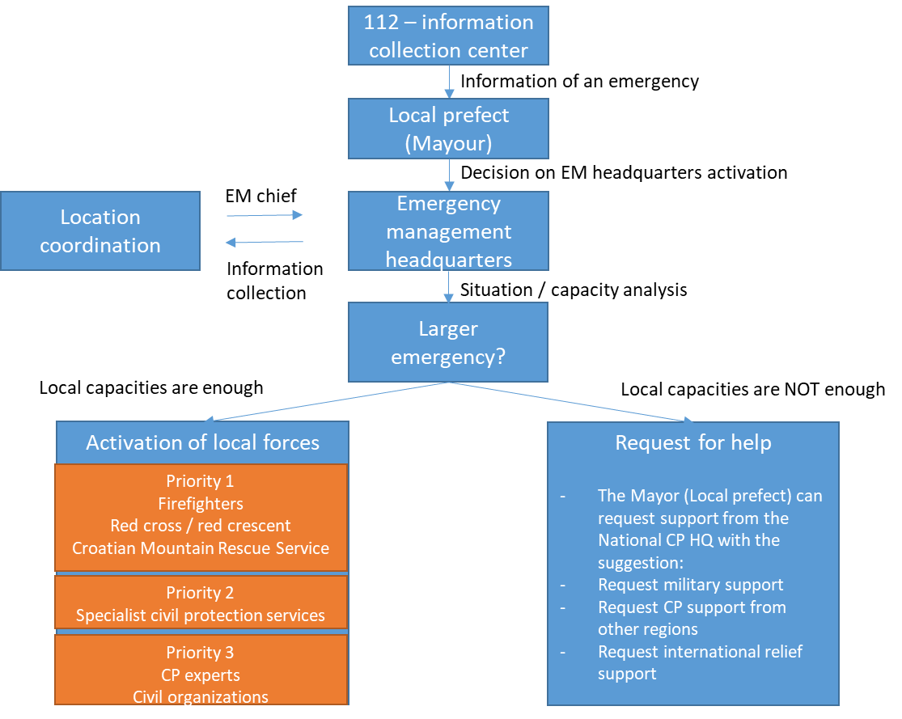
Figure 1. Activation process in case of an emergency

A good example for the crisis management activities was organized at the state level regarding the COVID 19 crisis. The CP headquarters at the state level considers all segments affected by the crisis caused by the COVID 19 pandemic and, based on the advice and recommendations of renowned experts for the pandemic situation (health, economy and economy, social aspects), adopts measures to mitigate or combat it. Pursuant to the Law on the CP System, the Chief of the CP Headquarters of the Republic of Croatia was the head of the Directorate for Civil Protection of the Croatian Ministry of the Interior. When a catastrophe was declared at the state level, the work of the Civil Protection Headquarters of the Republic of Croatia was taken over by the Prime Minister of the Republic of Croatia, who may delegate powers to a member of the Government or the Chief of the Civil Protection Headquarters of the Republic of Croatia. CP Directorate performs administrative and technical tasks and ensures the conditions for the work of the Civil Protection Headquarters of the Republic of Croatia.
Once the decision-making structure is clearly defined, the CP operational units and the CP units perform their tasks in accordance with their capabilities. CP units can be general purpose, specialist units and state intervention units. These are activated in accordance with the risk assessment and tasks to be performed. General purpose CP units are established at the level of local and regional self-government. They have the lowest readiness levels and are used to perform simpler tasks. Specialist CP units are also established at the level of local and regional self-government with the aim of performing more demanding tasks that require certain specific knowledge. The State Intervention Unit CP is established at the state level, which operates at the entire territory of the Republic of Croatia or in the international environment, and consists of a professional staff and a reserve unit. For the above-mentioned CP forces to be used correctly and economically, the on-site coordinator observes and assesses the situation on the ground and, in accordance with it, coordinates the work of the CP forces on site. The coordinator at the location is appointed by the Chief of the Civil Protection Staff from the ranks of the Central Committee in accordance with the crisis situation and is related to his experience and scope of work.
In cases when the crisis has escalated over the possibilities of the CP forces and no longer able to control the situation or the crisis situation is so specific that Military forces are required, the CP Directorate may request the support of Military forces through the Croatian Ministry of defence and the Office of the President of the Republic of Croatia [7]. The military forces are mainly used in protection and rescue operations, especially in the event of large forest fires, floods, earthquakes and pandemics.
3.3 Ministry of defence and crises
The Armed Forces of the Republic of Croatia (CAF) are constantly developing and maintaining military capabilities to respond to security challenges and threats, but today the traditional role of the military is changing and today it plays a significant role in all phases of management and response to the crisis [8].
The increased role of the army in the crisis management system poses new challenges to the CAF, which result in increased demands on the already complex military vocation.
In addition to the basic constitutional tasks of the CAF, which are to protect the sovereignty and territorial integrity of the Republic of Croatia and contribute to collective defence and international security, an important task of the defence system in peacetime is to support civilian institutions in the country [8]. The CAF, in cooperation with other security state elements and bodies, provides support to civilian institutions and the population in the crisis management process and in dealing with various types of risks and threats. Active cooperation of the CAF with security and other state elements and bodies by engaging the army in several non-military tasks aimed at increasing the security of Croatian citizens such as health, humanitarian aid, property protection and prevention and elimination of accidents and crises that ultimately result in greater security of Croatian citizens and enables much better and more efficient monitoring of the Adriatic Sea, submarine and coast of the Republic of Croatia.
The new role of the army in crisis situations affects its organizational structure, changes its personnel and material structure, and greatly affects the process of education and training of soldiers, non-commissioned officers, and officers. Thus, certain material resources are adapted to work in non-combat conditions (amphibians, working machines, helicopters ...). The use of the CAF outside the framework of classical military tasks represents the optimization and saving of state resources and the strengthening of the social role of the army through immediate social utility.
While CAF is supporting activities during crisis situations, care should be taken to ensure that all conditions are met for the military to engage in providing assistance and support to legal and natural persons outside the defence system. The basic condition for the engagement of the CAF is when the civil community does not have enough forces and resources to respond to a crisis or disaster.
Thus, today the CAF is mainly engaged in [9]:
- firefighting in the Republic of Croatia and abroad
- support to the health care system, emergency transport of the injured and seriously ill, as well as organ transplantation
- search and rescue on land (islands) and at sea by aircraft and vessels in cooperation with CP and Croatian Mountain Rescue Service
- aiding in flood defence
- supply of the population in the elimination of the consequences of drought on the mainland and islands and delivery of drinking water by tanks or ships of the Croatian Navy
- providing support during technical-technological crises
- providing support in the organization and implementation of exercises in the simulation center related to crisis management.
So far, uneconomical and uncoordinated management of state and other security elements and bodies has been observed. As an example of poor management in crisis situations, is related to the use of the Armed Forces of the Republic of Croatia (CAF). The main problem in the use of CAF resources is the extremely high cost of CAF engagement, reduction of the state's defence capabilities during the use of military resources for purposes other than those for which they are primarily intended, moving away from training and other planned CAF activities.
During crisis situations, the decision to use military forces should be made only after a political decision. Decisions should be made by the Government, and may include political and military measures, measures to address the civilian elements of the crisis, depending on the nature of the crisis. The Law on defence stipulates that the CAF may perform certain tasks in a state of imminent threat and provide assistance to civil government institutions and the population in the case of natural, technical-technological and environmental disasters. The use of the CAF during crisis situations is also defined by the Constitution of the Republic of Croatia, which states that the CAF can be used as an aid in natural disasters, rescue, supervision, and protection of the rights of the Republic of Croatia. Coordinated and economical use of the military and civilian segments (military in peace, civilian in war) in the defence and protection of residents, goods and the environment in crisis situations ensures a high degree of efficiency during crisis situations, better human resources and lower costs. Such a synergy between the military and civilian segments leads to no double procurement of equipment, construction of unnecessary parallel administrations and capacities. CAFs are primarily intended, equipped and trained to wage war, and their organizational structure, training and equipment in crisis situations caused by natural or technological disasters and catastrophes can come to full expression.

3. Republic of Croatia security system and its role in crisis situations
The organization of a country for the defence and protection of its inhabitants, goods and environment is the primary security and economic issue of every country. Therefore, it is necessary to organize this activity in an efficient and effective way in accordance with the priority tasks at the lowest possible cost.
The Republic of Croatia is building a crisis management system and strives to connect all components of such a system at the national level. Thus, it will provide faster and better aid, reduce the impact of the crisis, be less vulnerable and have better prevention, and thus greater resilience of society. The crisis management system, as part of the national security system of the Republic of Croatia, is extremely necessary, and its comprehensive approach in all phases of crisis management is important.

References

[1] | koronavirus.com, «Korornavirus - Službena stranica Vlade za pravodobne i točne informacije o koronavirusu,» Vlada Republike Hrvatske, 2020. [En línea]. Available: https://www.koronavirus.hr/. [Accessed: 02. 2021.].
[2] | NN, Zakon o sustavu civilne zaštite, NN 82/15, 118/18, 31/20, Zagreb: Narodne novine, 2020.
[3] | NN, Zakon o sustavu domovinske sigurnosti, NN 108/17, Zagreb: Narodne Novine, 2017.
[4] | M. Gill, The Handbook of Security, London: Palgrave Macmillan, 2014.
[5] | M. Raftari, «The role of crisis management in seisemic disaster,» Journal of Applied Sciences Research, vol. 5(9), 2011.
[6] | Z. Sigmund, M. Uroš, J. Atalić, «UNDRR The Earthquake in Zagreb amid the COVID-19 Pandemic: OPINION,» 30 April 2020. Available: https://www.undrr.org/news/earthquake-zagreb-amid-covid-19-pandemic-opinion. [Accessed: 22 02 2021].
[7] | NN, Zakon o obrani, NN 73/13; 75/15; 27/16; 110/17; 30/18; 70/19, Zagreb: Narodne Novine, 2019.
[8] | NN, Ustav Republike Hrvatske; NN 56/90, 135/97, 08/98, 113/00, 124/00, 28/01, 41/01, 55/01, 76/10, 85/10, 05/14, Zagreb: Narodne Novine, 2014.
[9] | NN, Strateški pergled obrane; NN 43/18, Zagreb: Narodne Novine, 2018.

