OUTWRESTLING TSUNAMIS WITH RESILIENT DESIGNS: MEETING THE CHALLENGE IN DUBROVNIK AND HILO

Mark N. White⁽¹⁾

⁽¹⁾ Principal, Law Offices of Mark N. White, Berkeley, California, mark.white@mnhitelaw.com

Abstract
Dubrovnik (Croatia) and Hilo (Hawaii, USA) are two urban centers that frequently face the challenges inherent in cataclysmic tsunamis. This paper will demonstrate better practices for incorporating dynamic aquatic forces in urban planning and project-specific landscape design for metropolitan waterfronts, drawing on the specific tsunami history of Dubrovnik and Hilo; it will also identify innovations in contemporary aquatic interface design. Design professionals can move beyond damage control to inclusion of dynamic aquatic forces in their waterfront rehabilitation projects, and thereby improve urban resiliency in urban centers such as Dubrovnik and Hilo, in the face of foreseeable tsunamis of the same magnitude that have been experienced.
Dubrovnik, Hilo and other urban centers with waterfronts have faced repeated tsunami attacks since they evolved into regional economic centers. Recent technical innovations in structural engineering have expanded the design options for meeting the challenges of foreseeable tsunami attacks in those centers. Design professionals can move beyond traditional preventative systems (such as sea walls) to include channels and robust high-rise framing systems in land forms that accept the dynamic tsunami surge rather than attempting to resist it (often in futility) with brute strength. This approach involves "outwrestling" tsunami forces by improving the ductility of man-made structures and water courses through performance-based design, following recent innovations in design methodology used in earthquake engineering. At its most fundamental level, improved resiliency follows a site-specific understanding of tsunami demand (in part derived from an honest understanding of historical attacks) and science-based predictions of performance based on capacity in excess of demand. This approach will produce better results than in earlier attacks, including reduced death, downtime and destruction.
Keywords: tsunami, Dubrovnik, Hilo, risk management

1. Introduction: Better Practices for Meeting the Tsunami Challenge
A tsunami is a natural hazard that can cause cataclysmic death, downtime and destruction within coastal urban centers. [1] For such centers, such as Dubrovnik (Croatia) and Hilo (Hawaii, USA), individual design professionals (e.g., landscape architects and structural engineers) and urban planners participate in a never-ending process of increasing the capacity of the coastal center to overcome the potentially catastrophic consequences of the tsunami surge. This process of improvement can be interpreted as a series of patterns, and analyzing them can assist designers and planners in achieving the performance targets that they select

This discussion will treat the tsunami as a set of ocean waves caused by a sudden dislocation of our planetary crust, usually arising from an underwater landslide or earthquake. [2] Long before the formation of the United States, Dubrovnik and other urban centers in the Mediterranean sustained cataclysmic losses because the collective capacity of the urban center was inadequate to meet the demands of the tsunami waves and their aquatic inundation of the built environment. The same cycle has more recently been studied in the State of Hawaii, including at Hilo Bay. [3]
While the hazards posed by tsunamis can be daunting, a pattern of managing tsunami risk in the built environment has emerged. First, tsunami ocean waves overrun the usual shoreline and inundate the built environment (including infrastructure, commercial and industrial facilities, as well as residential structures). Second, elements of the built environment fail to meet the inundation demand, and the ensuing unsatisfactory performance contributes to the destruction of property, and personal injury and/or loss of life. Third, the decimated areas in the urban center are repaired, repurposed and/or rebuilt under the auspices of designers and planners who are conscious of the most recent tsunami event (and, to varying degrees, of other destructive tsunamis). Fourth, later, and largely out of the limelight, modifications are made to the built environment which necessarily change the capacity of the urban center to meet the foreseeable tsunami demands. Fifth, another set of tsunami ocean waves inundate the newer urban configuration, losses are sustained and the process of recovery restarts.
Here, we argue that design professionals and planners should follow evolving best practices when undertaking the repair, repurposing and rebuilding of the coastal urban center both immediately after a cataclysmic tsunami and in the more distant future, as further refinement and development are undertaken. Specifically, they should employ technical advances in the design and construction of new urban elements in order to meet more rigorous performance targets that will yield proportionately less death, destruction and downtime when the next set of foreseeable tsunami waves overruns the usual shoreline.
As designers and planners strive to improve tsunami capacity, how do they bridge the gap between past performance and future improvements? A starting point is to derive lessons from past cataclysmic tsunamis. As Professor Christopher Arnold suggested, isolating seminal patterns “represents our current best guess as to what arrangement of the physical environment will work to solve the problem presented. The empirical questions center on the problem – does it occur and is it felt in the way we describe it? – and the solution – does the arrangement we propose solve the problem?” [4] Two recent aquatic inundation events will illustrate fundamental patterns that help us solve the problem of meeting the tsunami challenge, discussed further below with regard to Hilo and Dubrovnik.

2. Two Examples of Managing Aquatic Inundation
In October 2012, Hurricane Sandy caused $65 billion in damage to the United States. [5] Starting on October 29, 2012, part of this damage was sustained at Wall Street in lower Manhattan, where the storm surge inundated subways, tunnels, highways and streets with record-breaking levels of storm water. As a result, the primary financial center of the United States lost ordinary utility power for an extended time, which necessarily meant that the office towers housing financial institutions went dark, employees could not work, and billions of dollars of revenue were lost. But during the darkest hours, there was one significant exception on Wall Street: the high-rise housing Goldman Sachs was illuminated while virtually all the other towers were dark, and as a result, Goldman Sachs kept operating through the worst of the aquatic inundation, generating billions of revenues while its competitors were powerless and paralyzed. [ 6] Goldman Sachs outperformed its competitors because its management had invested in an independent power-generating system unlike others in Wall Street. It anticipated basement water inundation in foreseeable natural events and obtained special municipal permission to install its fuel and mechanical system several stories above grade rather than in the flood-vulnerable basement spaces customarily used in Wall Street. [7] This creative management approach to a foreseeable natural hazard enabled it to outperform its competitors when the natural hazard (Sandy) finally hit. This Goldman Sachs episode sheds light on a possible path for designers and planners to outperform others when their facilities and urban centers are hit by tsunami-driven aquatic inundations: use innovative techniques to minimize the potential damage, death and dislocations arising from foreseeable tsunamis.

On the island of Oahu, the United States Corps of Engineers (USCE) and the State of Hawaii somewhat belatedly met the challenge of invasive flood waters by creating sacrificial channels to protect local residences and their inhabitants. This local anecdote contains a pattern useful for our tsunami discussion. Five streams in the Keapuka Subdivision (City of Kaneohe, population 34,597 in 2010 and 33,241 in 2020) [8] had inadequate capacities to handle heavy rains. On February 4, 1965, the streams overtopped and flooded the subdivision, killing two residents and damaging or destroying 30 residential structures. No comprehensive mechanism was undertaken to increase capacity and the streams overtopped again four years later, on February 1, 1969, causing additional substantial residential damage in the same subdivision. In order to avoid another, third, inundation of the same subdivision, the USCE designed and built a dam (2,200 feet long and 75 feet high) and affiliated reservoir (with permanent pool capacity of 260 acre-feet and a maximum storage capacity of 3,800 acre-feet). Affiliated infrastructure was built to better handle flood waters, including storm sewer linkage to the local flood control district. Since its completion in 1980, the subdivision has not been overrun with floodwaters. The dam and reservoir cost $25.52 million and were incorporated into a 223 acre municipal botanical garden (Hoomaluhia) in a “highly urbanized area.” [9] Thereafter, additional residences were built in the same area. Thus, after two inundation events (four years apart), national and local governmental agencies stepped in and dramatically increased the infrastructure flooding capacity by spending $25 million to create artificial channels for foreseeable flooding, as well as building a reservoir to control excess floodwaters.
Does the historical record support a similar pattern in Hilo and Dubrovnik? Should developers improve the performance of their structures and should governmental entities create artificial channels and reservoirs to control tsunami inundations above and beyond the usual shoreline?

3. Dubrovnik History: “Filled the Whole of the Market Square with Water”
Dubrovnik (also known as Ragusa) is a coastal city situated on the Dalmatian coast, at the Southern end of Croatia, with a population in 2020 of approximately 25,000 (28,242 in 2011; approximately 50,000 in 1990; approximately 6,000 in 1667). [10] The Old City of Dubrovnik is known as the “Pearl of the Adriatic” and is on UNESCO’s World Heritage List because it has preserved “its beautiful Gothic, Renaissance and Baroque churches, monasteries, palaces and fountains.” [11] The city’s defensive stone walls are acknowledged as one of the most significant fortification systems of the Middle Ages, including an uninterrupted course of approximately 1,940 meters. [12] Sea walls were originally constructed to protect the city from sea-based attacks and range from 1.5 to 5 meters thick. [13]
At approximately 7:10 (UTC) on the morning of April 6, 1667, Dubrovnik was struck by a cataclysmic offshore earthquake and tsunami. Contemporaneous first-hand reports [14] support the following characterizations of the earthquake and the tsunami that it triggered:
- The surface wave magnitude of the earthquake was on the order of 7.2.
- The MMI was on the order of XI.
- Before the tsunami waves struck, the harbor waters receded “from the coast for a mile and then returned with great force.” Another report estimated that the waters receded from the coast “for almost 1,000 yards.”
- The maximum water height above ordinary sea level in the Bay of Dubrovnik was extraordinary.
- The intensity of the tsunami was at least 3-4.
- The Bay of Dubrovnik and the Old Town were inundated with at least four tsunami surges.
- The canals in Venice experienced extraordinary surges as well.

Robin Harris [15] summarizes similar contemporaneous reports as follows:
“Suddenly there was a deep rumbling, and a violent blow rocked the city. . . . A large part of the city collapsed. . . . The ground shook and crevasses opened up, swallowing completely some modest dwellings in the suburbs. The city walls swayed before falling back into position. . . . From out over the Adriatic there arose a roaring sound similar to continuous cannon fire. The sea withdrew from the harbor entirely and the ships moored there smashed their hulls on the now-exposed rock bed. Several times the tide returned and withdrew again.”
Harris estimates that 6,000 individuals lived within the walls of Ragusa at the time of the earthquake and tsunami, and that 2,000 perished as a result of the cataclysm. [16] More than half of the significant institutional facilities and nearly all residences were destroyed during and immediately after the earthquake. [17] “Most memorable for the population, however, was a tidal wave which filled the whole of the market square with water.” [18]
Table One summarizes the salient elements of the 1667 earthquake offshore the Dalmatian Coast and the resulting tsunami, as well as the resulting catastrophic losses sustained by Dubrovnik and its citizens.

TABLE ONE
TSUNAMI AT DUBROVNIK, CROATIA (RAGUSA)
APRIL 6, 1667 AT 07:10 (UTC)
TRIGGERING EVENT | MAG | MMI | DEATHS | RESIDENTIAL LOSSES | INSTITUTIONAL LOSSES | TRANSPORT LOSSES
Earthquake Offshore  Dalmatian Coast | M_{s} 7.2 | XI | 2,000* | Catastrophic: Nearly complete destruction | Heavy: More than half destroyed | Severe harbor and vessel damage
M_{s} = Surface Wave Magnitude. *Most deaths resulted from collapse and fires; unknown number of drowning deaths.

From Dubrovnik’s history a pattern emerges that tracks the aquatic inundation history at Kaneohe, Hawaii (described above). First, there is a destructive precedent (the 1667 cataclysm) that puts design professionals and planners on notice that the urban center is at risk of aquatic inundation following a severe natural event (here, tsunami inundation of the urban core followed a severe offshore earthquake). The next part of the pattern is open-ended: in addition to remediation of sea walls and other infrastructure after the 1667 tsunami, what other tangible steps have been taken to increase Dubrovnik’s capacity to handle a foreseeable tsunami hazard? How can developers improve the tsunami performance of their structures, and how can Dubrovnik’s governmental entities create artificial channels and reservoirs to control tsunami inundations beyond its walls and usual shoreline? Is it practical for Dubrovnik to invest in systems for managing aquatic inundation like local and national governmental entities did in Kaneohe, Hawaii?

4. Hilo History: Two Cataclysmic Tsunamis in the Last Century
Hilo is a coastal city on the largest of the Hawaiian Islands, with a population in 2020 of approximately 45,000 (43,263 in 2010; approximately 25,000 in 1946 and 1960). [19]. Conventional wisdom among Hawaiians is that “Hawaii is struck by more tsunamis than any other region in the world” and Hilo, in turn, is treated as the tsunami capital of Hawaii because of its coastal orientation. [20]
Hilo Bay faces the Pacific Ocean to the North. State Highway 19 runs North and South on the Western side of the Bay. The Eastern portion of Hilo Bay merges with Hilo Harbor to the East; this area is bounded by an L-shaped breakwater that terminates near commercial piers. Ocean access is to the West of the breakwater. Coconut Island is located a few hundred meters from the waterfront at the Western edge of Hilo Harbor. [21] Figures One and Two, attached the end of this paper, are maps depicting the most pertinent areas.
The core of the shoreline runs from the mouth of the Wailuku River on the West to the mouth of the Wailoa River on the East (immediately South of the mouth is Wailoa Bay, and south of that is Wailoa Pond). The distance between the two rivers is approximately 2.25 kilometers. Bridges span the mouths of both rivers and they are connected by State Highway 19, which traverses parkland and playing fields in the contemporary configuration of Hilo’s waterfront. Kamehameha Avenue runs parallel to Highway 19 for approximately 1 kilometer to the East of the Wailuku River, before it merges with Highway 19 for the next 1.25 kilometers to the Wailoa River mouth. Historically, the commercial core of Hilo has been situated to the South of Kamehameha Avenue.
When Captain George Vancouver anchored at Hilo Bay in 1794, King Kamehameha was based at Waiakea, a center a few kilometers to the South of Coconut Island, and was assembling a fleet of war canoes which were used to conquer the other Hawaiian Islands, which ultimately led to the consolidation of the Hawaiian Kingdom. [22]
After several years of construction, the Breakwater was completed in 1929. The prevailing local view is that the 3,072 meter long Breakwater was not designed to meet tsunami surges, but to facilitate mooring and cargo operations. [23]
Both before and after completion of the Breakwater at Hilo Bay, the urban core of Hilo experienced tsunamis that caused significant property damage, and occasionally, loss of life. Table Two identifies a subset of seven of those tsunamis between 1837 and 1975. In most instances, the maximum elevation of the tsunami above typical sea level (herein denominated “maximum water height”) exceeded 2.5 meters.
4.1 The 1946 Cataclysmic Tsunami
“On April 1, 1946 at 4:28 am (12:28 UTC), an 8.6 moment magnitude earthquake struck off the coast of Unimak Island in Alaska’s Aleutian Islands, generating a tsunami that caused the greatest damage and number of deaths in Hawaii’s history . . . . In Hawaii the waves reached about 17 m or 55 ft. high and killed 158 people, most in the town of Hilo . . . .” [24]
The maximum water height at the Hilo shoreline was estimated to be 6.1 meters. Inundation extended at least 800 meters inland from the shoreline. [25]
Elements of the 1946 inundation include the following:
- Breakwater at Hilo Bay. The tsunami waves overtopped the Breakwater and destroyed approximately 60 percent of it. “Giant blocks of stone, some weighing more than 8 tons, were strewn on the bayfront beach like grains of sand.” [26]
- Coconut Island. The island was inundated several times, including waves that overtopped its trees, on the order of 7 meters (roughly 25 feet) above ordinary sea level. [27]
- Wailuku River. Water levels rose several meters and flooded areas adjacent to the river banks.
- Wailoa River. Water levels rose several meters and flooded areas adjacent to the river banks.
- Railways and Roadways. The railway bridge at the mouth of the Wailuku River was sheared off its supports, and floated several hundred meters up-river, until the surge dissipated, at which point it floated seaward until it grounded on a small island a few hundred meters from the edge of the Bay. Conversely, the highway bridge was not destroyed. The railway terminus and railway tracks were destroyed. Kamehameha Avenue was inundated several times. [28]
- Commercial Facilities. Commercial piers and fishing boats were severely damaged. Commercial structures on the bay side of Kamehameha Avenue were swept off their foundations and strewn on and near the roadway. A tuberculosis hospital was flooded. [29]
- Housing. More than 500 homes and business facilities were destroyed. [30]
- Fatalities. At least 96 deaths resulted from the tsunami. [31]
- Value of Property Damage. In 2021 dollars, the estimated property damage in Hilo caused by the 1946 tsunami is $350 million.
After the 1946 tsunami, the land between Kamehameha Avenue and the bay front was converted from commercial use into a sacrificial buffer zone of recreation and parking facilities. Because the cost of constructing a sea wall to protect against tsunamis was determined o exceed the value of all structures in Hilo, the concept was not pursued. [32]
4.2 The 1960 Cataclysmic Tsunami
“On May 22, 1960, at 3:11 pm (19:11 UTC) the largest earthquake ever recorded by instruments struck southern Chile with a magnitude we now know to be at least 9.5. The earthquake generated a tsunami that traveled through every ocean on earth, though large, dangerous waves only impacted the coastlines around the Pacific Ocean. . . . [H]alfway across the Pacific Ocean Hawaii suffered the second-worst tsunami in its recorded history—only the Aleutian Islands tsunami of 1946 was worse. It killed 61 people in the town of Hilo with waves reaching as high as 10.7 m or about 35 ft. . . . .” [515.1]
The following map depicts the area of tsunami inundation during the 1960 event. [34]
Elements of the 1960 inundation include the following:
- Breakwater at Hilo Bay. It was overtopped by at least 10 meters.
- Coconut Island. By 01:05, Coconut Island was flooded. Its footbridge, rebuilt three times after the 1946 tsunami, was swept away. [35]
- Wailuku River. After the second wave, near the River mouth, the water was approximately 2 meters below ordinary sea level. “The floodwaters inundated approximately 580 acres between the Wailuku River and the shoreward end of the breakwater.” [36]
- Wailoa River. “Between the Wailoa and Wailuku rivers the water washed inland as far as the 20-foot contour above seal level.” [37]
- Railways and Roadways. Kamehameha Avenue was flooded by the second tsunami wave at 00:46, with a wave height of more than 2.5 meters. “Thirty-foot lengths of concrete curbing from the Bayfront Highway [parallel to Kamehameha Avenue] were carried 350 feet inland.” [38]
- Commercial Facilities. The Hawaiian Electric Power plant exploded and was disabled by flooding at 01:05, and at approximately the same time much of the commercial damage was sustained all along the waterfront. After the second wave, a bore roughly 10 meters in height inundated Kamehameha and the heart of the commercial district. The tsunami wave “wrenched 22-ton boulders from the 10-foot height bayfront seawall and carried them as far as 600 feet inland . . . . “ Elements of a hardware store located on Kamehameha Avenue “were later found 1,500 feet away beyond the Wailoa river.” Entire “city blocks were swept clean.” Losses included substantial damage to 508 business and government structures. The following municipal systems were destroyed: domestic water; sewage treatment; storm drainage; electrical generation. [39]
- Housing. “The business district along Kamehameha Avenue and the adjoining low-lying residential areas of Waiakea and Shinmachi were literally wiped off the map.” Losses included serious damage to 229 dwellings. [40]
- Fatalities. 61 deaths.
- Value of Property Damage. In 2021 dollars, the estimated property damage in Hilo caused by the 1960 tsunami was $440 million. See Table Two below for comparison with others.
- Aftermath. After the 1946 tsunami, many of the damaged commercial operations and dislocated households moved away from the buffer zone to other low-lying areas in Waiakea and Shinmachi. These areas bore the brunt of property damage and loss of life during the 1960 tsunami, after escaping serious damage in the moderate 1952 and 1957 tsunamis. “Just 8 days after the 1960 Tsunami, the Hawaii Redevelopment Agency was established. The ocean side buffer zone was extended and a landfill plateau was constructed, raising the inland border of the greenbelt 26 feet above sea level.” “[M]uch of the downtown business district was rebuilt further inland. The inundation zone is now largely soccer fields and public park land.” [41]
The same pattern that we saw in Dubrovnik imposes itself on Hilo, only more frequently. How can developers improve the tsunami performance of their structures in Hilo, and how can Hilo’s governmental entities create artificial channels and reservoirs to control tsunami inundations beyond its Breakwater and usual shoreline? Is it practical for Hilo to invest in systems for managing aquatic inundation like local and national governmental entities did in Kaneohe, Hawaii?

5. Paving the Way toward Better Practices for Managing Tsunami Risk: Advances in Earthquake Engineering
One of the harsh lessons of the 1946 and 1960 cataclysmic tsunamis is that loss of life and property destruction can be reduced in future tsunamis if core commercial districts and residential neighborhoods are excluded from the most vulnerable areas along the urban waterfront. Put another way, planners can designate low-lying areas to be “buffer zones” and developers can rely on their design consultants to predict satisfactory tsunami performance taking into account the inundation hazard inherent in areas near the shoreline. Best practices are dependent on reliable technical information, including awareness of past unacceptable facility performance during tsunami inundation. Moreover, the best practice of creating tsunami buffer zones is only part of the evolving set of strategies necessary to manage tsunami risk.
Technological innovation in seismic engineering prompts us to reformulate and expand the set of best practices for managing risk arising from tsunamis, including those experienced by Dubrovnik and Hilo. During the last 50 years, the evolution of earthquake engineering techniques has improved earthquake risk management for both private developers and public regulatory institutions. Individual facilities built with innovative elements now have greater capacities to meet the challenges of severe earthquakes. Under the auspices of modern regulation and planning, the same is true for the macro design of urban centers in active seismic zones. [42]
One of the realities that has emerged in the United States during the last 50 years is that performance targets that control structural designs have evolved from merely avoiding collapse during an earthquake to minimizing property damage and maximizing functionality promptly after the seismic event. [43] In order to meet these enhanced performance targets, structural engineers and their design team colleagues have developed new techniques for minimizing natural hazard damage and accelerating essential repairs to facilitate post-event functionality. Two university projects will illustrate this pattern.
At the University of Southern California, before its completion, the design for a new Cinematic Arts Complex was initiated during 2006. The owner mandated that the new facility remain functional for at least 100 years (hence, owner’s performance target was a “100 year building”). The structural engineers anticipated at least one severe earthquake during that time frame and developed a novel structural element to provide both reliable earthquake performance and easy, rapid repair: designated sacrificial fuses (denominated “Krawinkler Fuses”) to protect the principal load-bearing elements from any significant damage, which would be easily replaced promptly after the earthquake. [44] This concept of sacrificial structural elements to protect the principal load-bearing elements can also be refined and further developed in the context of tsunami risk management.
At Harvard University, before construction was completed in 2020, the design team of the new Science and Engineering Complex (“SEC”) aspired to develop a “500 year building.” Water inundation from foreseeable flooding on the nearby Charles River was one hazard that the design team had to manage. As was the case in the Goldman Sachs project described above, the operative design evolved to make the facility compatible with expected aquatic inundation: essential mechanical systems were repositioned and land forms were modified to better channel flood waters. Using the latest Army Corps of Engineers editions of the 500-year flood maps for the Charles River area better enabled the SEC design team to address the challenge of inevitable flooding. [45]

6. Conclusion: Updating Techniques for Managing Aquatic Inundation
The Harvard SEC project is a useful illustration of a principle that can help designers facing the tsunami challenge: using the best technical information available can enable the design team to reshape land forms to channel aquatic surges. For instance, recent computer modeling suggests that “the main protective benefit of tsunami mitigation parks is the reflection of wave energy” and, accordingly, reflection of the tsunami’s wave energy “can be maximized through strategic design of the park’s hillscape, at least for tsunami amplitudes that are comparable to hill height.” [46] In the case of the Hilo Bay, reduction of tsunami risk may be better achieved by increasing the hillscape along the borders of the Wailuku and Wailoa rivers, instead of investing in a traditional sea wall that relies on brute strength. Channeling the tsunami surge in Hilo Bay toward the two rivers and creating an up-river reservoir to temporarily retain the inundation may well improve performance beyond that of 1946 and 1960 (i.e., less death, destruction and downtime). Similarly, artificial hills near Dubrovnik’s Old Town may be able to reflect intrusive energy toward the strongest natural points of the bay. Computer analysis of these hypothetical configurations is now possible in ways unthinkable 50 years ago.
Finally, innovations in vertical evacuation design have started to make inroads that were barely discussed 50 years ago. In the Pacific Northwest of the United States, which faces the Cascadia Subduction Zone and a tsunami hazard much like that faced in Dubrovnik, several public projects have been undertaken to incorporate sacrificial lower stories in relatively tall structures, to provide individuals with elevated safe havens when the suddenness of a cataclysmic tsunami limits escape options. [47] This design approach could save hundreds of lives in Hilo and Dubrovnik as new facilities are added to their respective sea shores, within reach of future tsunami inundations.

TABLE TWO
TSUNAMIS AT HILO, HAWAII (USA)

TRIGGERING EARTHQUAKE | MAG | MMI | MAX WATER HEIGHT | DEATHS AT HILO | RESIDENTIAL LOSSES | INSTITUTIONAL LOSSES | TRANSPORT LOSSES | DOLLAR LOSSES (MM)
Tsunami on November 7, 1837 at 19:00 following Earthquake on November 7, 1837 at 12:51 (UTC)
1837 Offshore  Valdiva | M_{s}  8.0 | X | 6.0 m | 14 | Heavy | Heavy | Harbor and vessel damage | NA
Tsunami on April 3, 1868 at 15:40 following Earthquake on April 3, 1868 at 02:30 (UTC)
1868 Great Ka’u* (Hawaii) | M_{fa}  7.9 | X | 2.7 m | 0 | Moderate | Moderate | Harbor and vessel damage | NA
Tsunami on February 3, 1923 at 12:30 following Earthquake on February 3, 1923 at 16:01 (UTC)
1923 Kamchatka | M_{w}  8.4 | VII | 6.0 m | 1 | Moderate | Moderate | Railway | $184
Tsunami on April 1, 1946 at 06:55 following Earthquake on April 1, 1946 at 12:28 (UTC)
1946 Offshore  Unimak Island | M_{w}  8.6 | VII | 6.1 m | 96 | Heavy | Heavy | Bridges  Railway | $350
Tsunami on May 22, 1960 at 00:07 following Earthquake on May 22, 1960 at 19:11 (UTC)
1960 Valdiva** | M_{w}  9.5 | IX | 10.7 m | 61 | Heavy | Heavy | Harbor and vessel damage | $440
Tsunami on March 27, 1964 at 11:45 following Earthquake on March 28, 1964 at 03:36 (UTC)
1964 Prince WilliamSound | M_{w}  9.2 | X | 3.8 m | 0 | Moderate | Moderate | Harbor and vessel damage | $219
Tsunami on November 29, 1975 at 03:35 following Earthquake on November 29, 1975 at 14:47 (UTC)
1975 Kalapana*** | M_{w}  7.7 | VIII | 2.6 m | 0 | Moderate | Moderate | Harbor and vessel damage | $146
M_{s} = Surface Wave Magnitude. M_{w} = Moment w-phase. M_{fa} = Felt Area Magnitude
*Largest recorded earthquake in Hawaii. **Largest earthquake of 20th century. ***Largest earthquake in Hawaii since 1868.

Figure One – Hilo Shoreline between Two Rivers
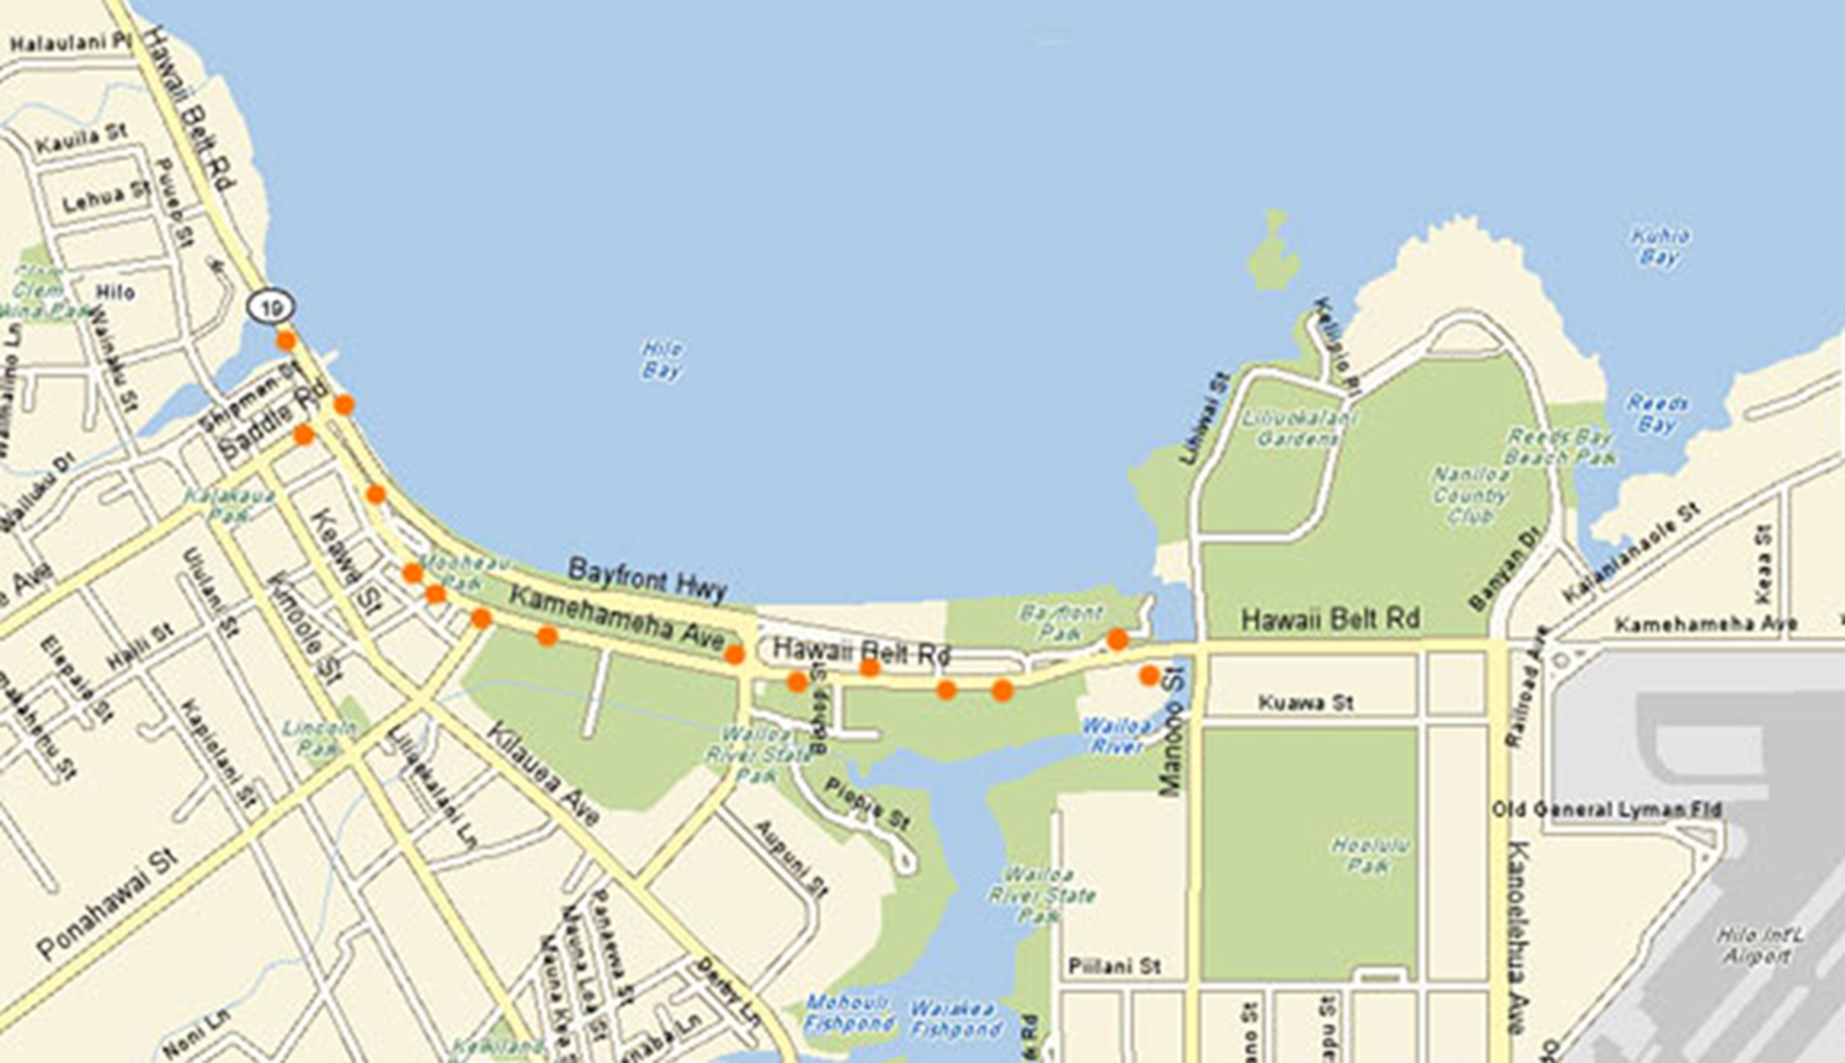

Figure Two – Aquatic Inundation of Hilo Bay during 1964 Tsunami
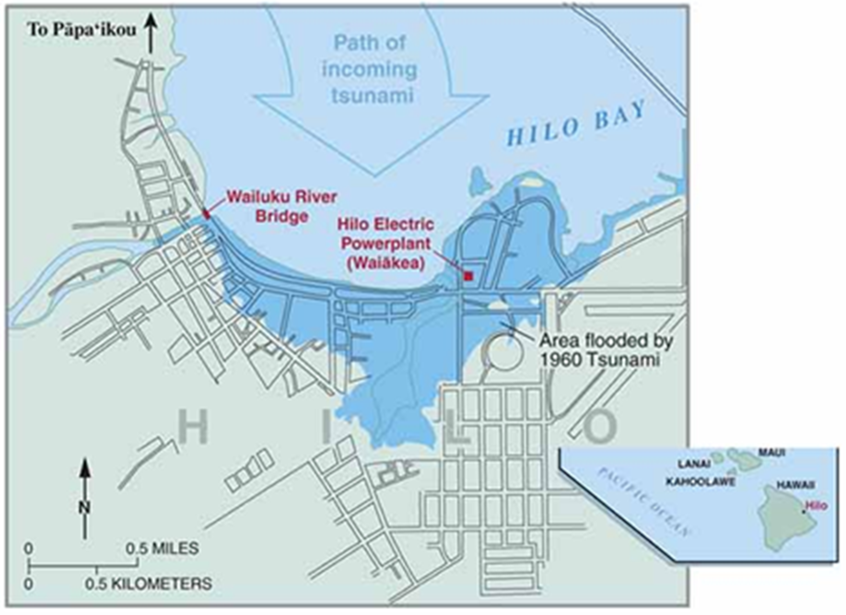

7. References
[1] United States Geological Survey, Surviving a Tsunami – Lessons from Chile, Hawaii, and Japan (2005) https://pubs.usgs.gov/circ/c1187/, accessed February 15, 2021, hereinafter referred to as “Tsunami Lessons”
[2] Ibid.
[3] W.C. Dudley, M. Lee, Tsunami! (2nd Ed., University of Hawaii Press, Honolulu) (1998), hereinafter referred to as “Dudley & Lee”
[4] C. Arnold, A Pattern Language: Towns, Buildings, Construction (Oxford University Press) (1977) preface
[5] National Oceanic and Atmospheric Administration, Costliest U.S. tropical cyclones tables updated (January 26, 2018) https://www.nhc.noaa.gov/news/UpdatedCostliest.pdf, accessed February 15, 2021
[6] A. Tangel, Stock markets to stay dark Tuesday, Los Angeles Times (October 29, 2012) https://www.latimes.com/business/la-xpm-2012-oct-29-la-fi-mo-stock-market-closed-on-tuesday-20121029-story.html, accessed February 15, 2021
W. Alden, Around Goldman’s Headquarters, an Oasis of Electricity, The New York Times (November 2, 2012) https://dealbook.nytimes.com/2012/11/02/around-goldmans-headquarters-an-oasis-of-electricity/, accessed February 15, 2021
K. Roose, Goldman Sachs Was Not Washed Away in Hurrican Sandy [Updated], New York Magazine (October 30, 2012) https://nymag.com/intelligencer/2012/10/goldman-sachs-survived-hurricane-sandy.html, accessed February 15, 2021
[7] Author interviews at Third International Conference on Urban Disaster Reduction: Addressing Risks and Uncertainty, University of Colorado, Boulder (September 28 – October 1, 2014)
[8] See the United States Census website for Kaneohe https://www.census.gov/quickfacts/kaneohehawaii, accessed February 15, 2021
[9] United States Corps of Engineers, Civil Works Projects/Kaneohe/Kailua Area, https://www.poh.usace.army.mil/Missions/Civil-Works/Civil-Works-Projects/Kaneohe-Kailua-Area/, accessed February 15, 2021
Department of Land and Natural Resources, Hawaii’s Dams -- What are they used for??, Hawaii Flood Management News (June 2006), https://dlnreng.hawaii.gov/nfip/wp-content/uploads/sites/11/2013/03/2006_june.pdf, accessed February 15, 2021
[10] Population of Dubrovnik, http://population.city/croatia/dubrovnik/
https://www.dzs.hr/Eng/censuses/census2011/results/htm/E01_01_01/e01_01_01_zup19_0981.html, accessed February 15, 2021
[11] Unesco, World Heritage List, https://whc.unesco.org/en/list/95/, accessed February 15, 2021
[12] Encyclpaedia Britannica, Dubrovnik, https://www.britannica.com/place/Dubrovnik, accessed February 15, 2021
[13] M.Zabcic, The City Walls of Dubrovnik,
http://www.geographica.hr/site/public/download/project_city_walls_of_dubrovnik.pdf
http://w3.leica-geosystems.com/media/new/product_solution/Leica_Geosystems_TruStory_The_City_Walls_of_Dubrovnik.pdf, accessed February 15, 2021

[14] United States National Oceanic and Atmospheric Administration/National Centers for Environmental Information, Tsunami Data and Information https://www.ngdc.noaa.gov/hazel/view/hazards/tsunami accessed on January 7, 2021
D.J. Leeds, Report 64-6: The Skopje, Yugoslavia Earthquake of July 26, 1963, Dept. of Engineering, University of California at Los Angeles (1964) at p. 64
S.L. Soloviev, O.N. Solovieva, C.N. Go, K.S. Kim, N.A. Shshetnikov, Tsunamis in the Mediterranean Sea 200 B.C. – 2000 A.D., Advances in Natural and Technological Hazards Research, Vol. 13 (Kluwer Academic Publishers, Dordecht, Netherlands) (2000) at p. 237
[15] R. Harris, Dubrovnik: A History (Saqi Books, London) (2006) at p. 350
[16] Id. at p. 367-369
[17] Id. at p. 368-369
[18] Id. at p. 369
[19] See the United States Census website for Hilohttps://www.census.gov/quickfacts/hilocdphawaii, accessed February 15, 2021
[20] Dudley & Lee at p. 338. The International Tsunami Information Center is located in Honolulu, the capital of Hawaii. Itic.ioc – unesco.org
[21] Pacific Tsunami Museum, Interactive Hilo Bay Map, http://tsunami.org/interactive-hilo-bay-map/, accessed February 15, 2021
[22] P.T. Young, Hilo Bay and Breakwater, Images of Old Hawaii (March 20, 2020) http://imagesofoldhawaii.com/hilo-bay-and-breakwater/, accessed February 15, 2021
[23] Ibid.
[24] National Oceanic and Atmospheric Administration, Tsunami Historical Series: Aleutian Islands - 1946, https://sos.noaa.gov/datasets/tsunami-historical-series-aleutian-islands-1946/, accessed February 15, 2021
[25] See Dudley & Lee at p. 47
[26] Dudley & Lee at p. 47
[27] Dudley & Lee at pp. 26-27, 48
[28] Dudley & Lee at pp. 17, 35, 43
[29] Dudley & Lee at pp. 20, 36-37
[30] Dudley & Lee at p. 42
[31] Ibid.
[32] Dudley & Lee at pp. 175-176, 330
[33] National Oceanic and Atmospheric Administration, Tsunami Historical Series: Chile - 1960 https://sos.noaa.gov/datasets/tsunami-historical-series-chile-1960/, accessed February 15, 2021
See also USGS, Volcano Watch – Tsunami threat real in Hawaii (submitted title: The 1960 tsunami, Hilo), https://www.usgs.gov/center-news/volcano-watch-tsunami-threat-real-hawaii-submitted-title-1960-tsunami-hilo, accessed February 15, 2021 (hereinafter “Volcano Watch”)
[34] Volcano Watch
[35] Volcano Watch
[36] Dudley & Lee at pp. 166, 172
[37] Dudley & Lee at p. 172
[38] Dudley & Lee at pp. 147-153, 169
[39] Dudley & Lee at pp. 166, 168, 172
[40] Dudley & Lee at p. 172
[41] Dudley & Lee at pp. 176, 332
[42] See, for instance, the Community Safety Element of the San Francisco General Plan, ttps://generalplan.sfplanning.org/Community_Safety_Element_2012.pdf, accessed on February 15, 2021
[43] M.N. White, P. Yanev, Paper No.C001084 The Evolution of Managing Seismic Risk in American Urban Centers after the Loma Prieta Earthquake: Changes in California Authorities and Federal statutes After 1989, 17th World Conference on Earthquake Engineering (Sendai 2021). A copy of this paper is available from the authors on request.
Advances in computing have dramatically improved the ability of structural consultants to predict which particular structural system will perform best in foreseeable earthquakes. See, e.g., V. Terzic, S. Mahin, Using PBEE to Assess and Improve Performance of Different Structural Systems for Low-Rise steel Buildings, 17th World Conference on Earthquake Engineering (Sendai 2021).
[44] G. Luth, J. Osteraas, J. Hunt, Delivering Enhanced Seismic Performance and Resiliency through the Use of Krawinkler Fuses: Three Case Studies, 17th World Conference on Earthquake Engineering (Sendai 2021)
[45] Harvard University, Institutional Master Plan Amendment, Science and Engineering Complex (Rev. April 2016) at p. 39 (PDF page 47/88)
http://www.bostonplans.org/getattachment/55feda0c-81fe-40b4-8033-1ab06cf48bfd,accessed February 15, 20201
J. Shaw, “A 500-Year Building,” Harvard Magazine (January-February 2021) https://harvardmagazine.com/2021/01/jhj-new-harvard-seas-center, accessed on February 15, 2021
See also https://www.seas.harvard.edu/tour/allston/1/science-and-engineering-complex
[46] B. Lunghino, A.F. S. Tate, M. Mazereeuw, A. Muhan, F. X. Giraldo, S. Marras, J. Suckale, The protective bnefits of tsunami mitigation parks and ramifications for their strategic design, Proceedings of the National Academy of Sciences of the United States of America (2020) https://www.pnas.org/content/117/20/10740, accessed February 15, 2021
[47] J. Schelling, Project Safe Haven: Tsunami Vertical Evacuation Systems on Washington State’s Pacific Coast, Federal Emergency Management Agency (2014)
Washington Emergency Management Division, Project safe Haven: Tsunami Vertical Evacuation on the Washington Coast (2014)
Federal Emergency Management Agency, Guidelines for Design of Structures for Vertical Evacuation from Tsunamis FEMA P-646 (2nd Ed. April 2012)

