CURRENT STATUS AND PERSPECTIVES ON SEISMIC MONITORING OF STRUCTURES AND RAPID SEISMIC LOSS ESTIMATION IN ROMANIA

Alexandru Tiganescu(1), Dragos Toma-Danila(2), Bogdan Grecu(3), Iolanda-Gabriela Craifaleanu(4), Stefan Florin Balan(5), Claudiu Sorin Dragomir(6)

(1) Researcher & PhD Student, National Institute for Earth Physics, Magurele, Romania & Technical University of Civil Engineering Bucharest, Romania, [alexandru.tiganescu@infp.ro](mailto:alexandru.tiganescu@infp.ro)

(2) Senior Researcher, National Institute for Earth Physics, Magurele, Romania, [toma@infp.ro](mailto:toma@infp.ro)

(3) Senior Researcher, National Institute for Earth Physics, Magurele, Romania, [bgrecu@infp.ro](mailto:bgrecu@infp.ro)

(4) Associate Professor & Senior Researcher, Technical University of Civil Engineering Bucharest, Romania & National Institute for Research and Development in Construction, Urban Planning and Sustainable Spatial Development “URBAN-INCERC”, Romania, [iolanda.craifaleanu@utcb.ro](mailto:iolanda.craifaleanu@utcb.ro), [i.craifaleanu@gmail.com](mailto:i.craifaleanu@gmail.com)

(5) Senior Researcher, National Institute for Earth Physics, Magurele, Romania, [sbalan@infp.ro](mailto:sbalan@infp.ro)

(6) Associate Professor & Senior Researcher, University of Agronomic Sciences and Veterinary Medicine of Bucharest, Romania & National Research and Development Institute for Building, Urban Planning and Sustainable Spatial Development, Romania, [dragomirclaudiusorin@yahoo.com](mailto:dragomirclaudiusorin@yahoo.com)

# *Abstract*

The management of emergency situations generated by natural or man-made disasters is a worldwide critical task for both public and private entities. In Romania, seismic hazard represents one of the most dangerous threats, in terms of potential physical and socio-economic losses. In recent years, taking advantage of the new technology developments and increase of the computational power, significant improvements have been done for seismic risk mitigation, using automatic systems and real-time data. There are two main institutions that perform real-time seismic monitoring of structures in Romania: INFP and URBAN-INCERC. A system for rapid damage and loss assessment (Seisdaro) is currently running at INFP, using post-earthquake generated ShakeMaps, while URBAN-INCERC is in the process of implementing a structural health monitoring system for instrumented buildings in its network, based on the ARTeMIS software. A brief history on the evolution of seismic monitoring of building structures and rapid seismic loss assessment in Romania will be presented. The paper also covers general lessons learned from previous earthquakes that affected the country, data regarding past and present exposure datasets, country-specific fragility functions and various methods and algorithms used for structural health monitoring over the time. Through international and national projects, constant improvements have been done regarding the seismic monitoring of structures and loss estimation. The roadmap for future developments involving the main institutions in charge of the seismic risk reduction, including research, academia and authorities, will be also outlined. Finally, given the complex situations revealed by the pandemic and its potential conjunction with other hazards, some reflections are presented about new multi-disciplinary methods and concepts that should be developed, implemented and tested, taking into account more variables such as: social vulnerability, influence of transportation networks and hospital capacities. The validation of these methods should help both private and public entities to increase life safety, to reduce economic losses and downtime.

*Keywords: seismic monitoring, structures, loss estimation, Romania.*

# 1. Introduction

Seismic monitoring of structures has become a topic of interest for both public and private entities willing to determine and track the integrity of structures over time and to increase their serviceability.

Given that in Romania (especially Bucharest) a large number of buildings were designed in non-compulsory seismic design code periods (more than 40% of residential buildings at national level and more than 44% in Bucharest constructed before 1960, according to the 2011 National Census), the preparation and large-scale implementation of monitoring and rapid damage assessment tools can prove crucial for assisting specialists and decision-makers in strategically establishing and prioritizing the retrofit of affected building stock.

The paper presents an overview of the current status of Structural Health Monitoring (SHM) and rapid seismic loss estimation in Romania. Finally, future short-term and long-term perspectives will be highlighted, given the collaborative involvement of the National Institute for Earth Physics (INFP) and the National Research and Development Institute for Building, Urban Planning and Sustainable Spatial Development (URBAN-INCERC) in research projects and in a coordinated effort to improve the legislation in the field.

# 2. Seismic monitoring of structures

A critical activity for a seismic country is to monitor and track the condition of its build environment, in order to ensure the life safety of the population and recovery after an extreme event. The necessity of this type of data has proved beneficial both in the research studies, but also in emergency situations, including some that occurred recently [1, 2]. The economic considerations, as discussed in [3] play also an influential role. The condition assessment of aged structures is more and more becoming a critical issue for civil infrastructures, especially when developing life-extension and replacement strategies. The initial added cost of the monitoring system and its maintenance are expected to prevent much greater subsequent investments in the construction and operability of structures. The direct benefits of such a system include, among others: real-time monitoring and periodical reporting or reporting after extreme events; assistance in post-earthquake building inspection; reduction in downtime (business continuity); reduced long-term maintenance cost; increased safety and system reliability.

**2.1 Brief history and developments**

The research in the field of SHM, was initiated back in the ‘70s, with a special focus on the aerospace and gas exploration industry. However, at that time, a significant discrepancy could be noticed between theoretical concepts and their practical applicability, due to the lack of standardisation.

In Romania, SHM using experimental recorded data has a rather long history, starting in the 1960’s, when various buildings were instrumented for scientific purposes. The data collected before and after the MW=7.4 1977 earthquake [1], revealed that low damage was associated with an increase of natural periods up to 25%, light damage may increase periods with 25 - 50%, while systematic and significant damage resulted in the increase of fundamental periods by more than 50%. [4]. The seismic monitoring of structures has recently gained additional momentum with the inclusion of specific provisions, first in the 2006 edition of the Romanian seismic design code, P100-1/2006 [5] and then in the current edition, P100-1/2013 [6]. As stated in the code, instrumentation should be done for buildings in the first importance-exposure class, as well as for buildings higher than 45 meter above ground level, in areas where the design value of the peak ground acceleration is equal to 0.25 g or greater. Moreover, a Ministerial Order from 2005 requires that all the public institutions and private entities instrument their buildings if those are more than 50 meter-high, have more than 16 stories or have a developed area of more than 7500 m2.

There are two main institutions that perform real-time seismic monitoring of structures in Romania: URBAN-INCERC and INFP. Building instrumentation has been used at URBAN-INCERC for SHM ever since the late 1960s. In the recent years, INFP has also started a campaign to instrument some representative structures in urban areas, in order to have a better understanding on their response to earthquakes and ambient vibrations. Another important institution that is working on this topic is the Technical University of Civil Engineering Bucharest, UTCB. During the JICA (Japan International Cooperation Agency) project, UTCB has instrumented four representative buildings [7], two of those being the Romanian National Television, TVR (14 storey-high), and the BRD-SG Tower (20 storey-high). Several studies, consisting in detailed time-domain and frequency-domain analyses were conducted for the latter, a reinforced concrete building located in Bucharest. Demetriu and Aldea [8] have investigated the variation of the modal frequencies of the building from ambient vibration data and earthquake data. The soil-structure interaction (SSI) effect was also highlighted, using free-field stations located close to the building and borehole data. [9]. In 2013, in a study conducted by Perrault et al. [10], the experimental data acquired from the BRD-SG Tower were used to reduce the uncertainty of the single-building fragility curve. To achieve this goal, the earthquake data were input in an algorithm for the validation of building model, based on the Timoshenko beam approximation.

Another structure instrumented by UTCB was the Faculty of Civil, Industrial and Agricultural Buildings (FCCIA) of this university. The numerical model was validated with experimental data recorded during ambient vibration monitoring sessions. The SSI effect was also investigated, slight soil structure interaction effects being reported, with no significant numerical effect, however [11]. Besides the main institutions above, there are also a few SHM initiatives from the private sector, still in their incipient stage.

**2.2 Current status of SHM in Romania**

The National Network for the Seismic Monitoring and Protection of Building Stock of URBAN-INCERC consists of 26 stations (brown squares, Fig. 1), located in low-, medium- and high-rise buildings; with 20 of these being accessible online. Part of the buildings have sensors both in the basement (or on the ground floor) and at the top, while some of them have sensors installed only on the ground floor.

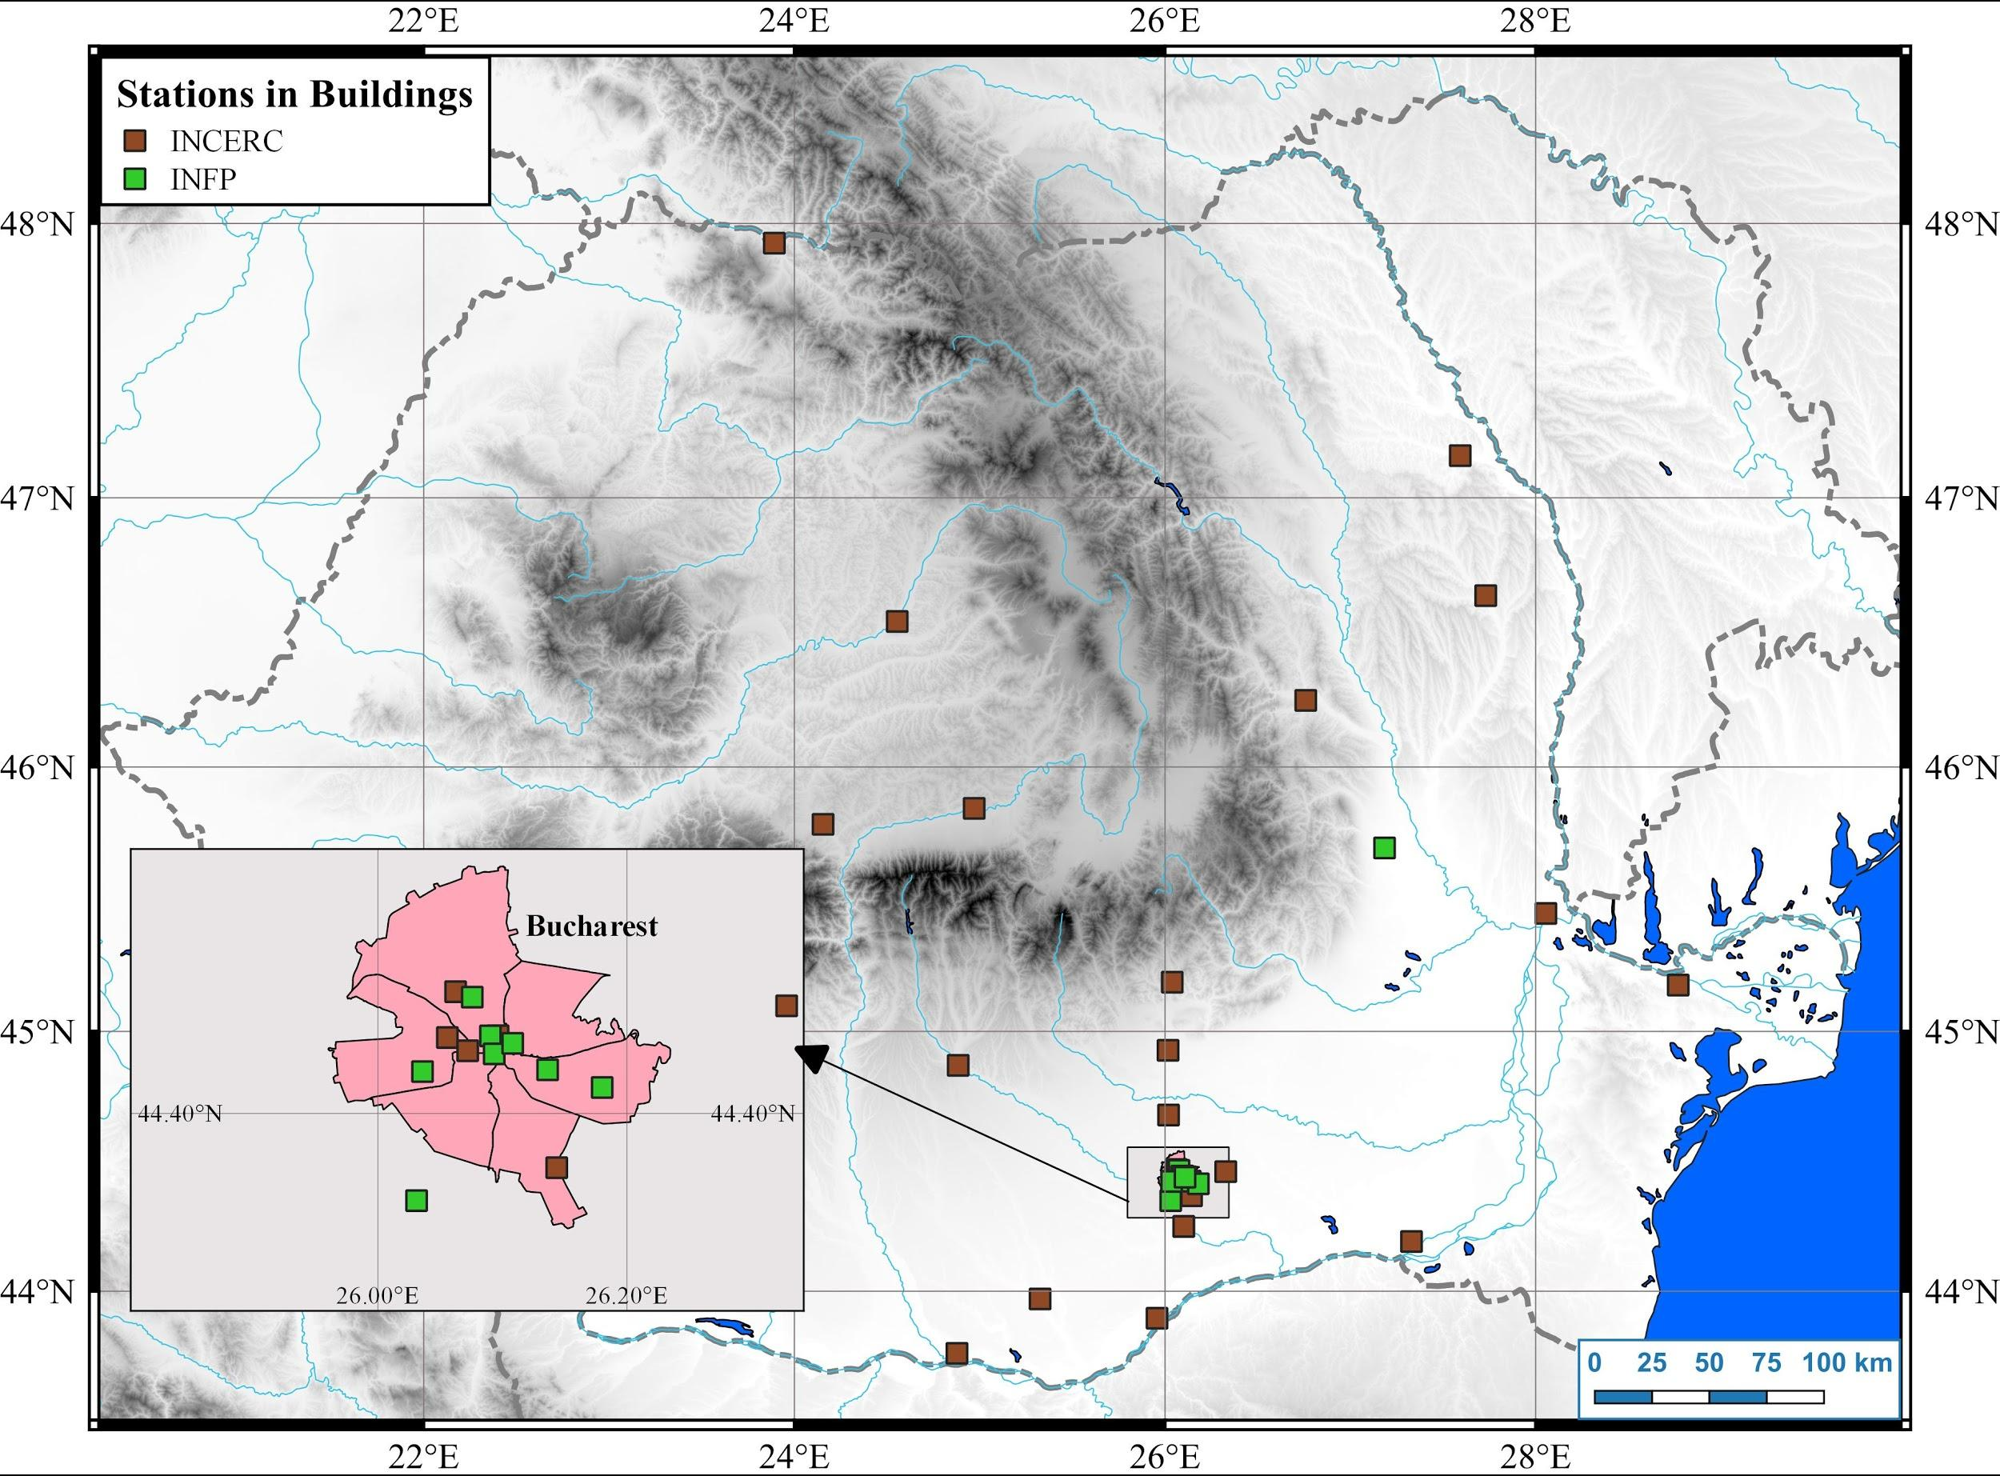

Figure 1. The current map of the seismic stations installed in buildings, by URBAN-INCERC and INFP in Romania and a detailed picture of Bucharest.

In what concerns SHM performed by INFP, up to now, there are five instrumented structures that transmit real-time data to the INFP`s National Data Center, while five more buildings were instrumented recently (in 2020) in the framework of the EU-funded TURNkey Project. The real-time data acquisition and archiving is performed using the Seiscomp3 system. The instrumentation scheme consists mainly in accelerometers located at the ground (or basement) level, at an intermediate floor and on the roof, thus being able to capture the global response of the building (Fig. 2).

The monitoring system is used, at INFP, for: determining the dynamic characteristics of the structure (natural frequency, damping) and their evolution over time; rapid automated determination of earthquake engineering parameters: time series for acceleration, velocity and displacement or peak values (PGA, PGV and PGD), response spectra, Fourier spectra and spectral reports (Fig. 3), CAV, Arias or Housner Intensity etc. Based on this data, studies on the dynamic characteristics of buildings from ambient vibration data were conducted in [12] as well as on the earthquake data recorded on the instrumented buildings from the last moderate earthquake (Oct 28th, 2018), as described in [13].

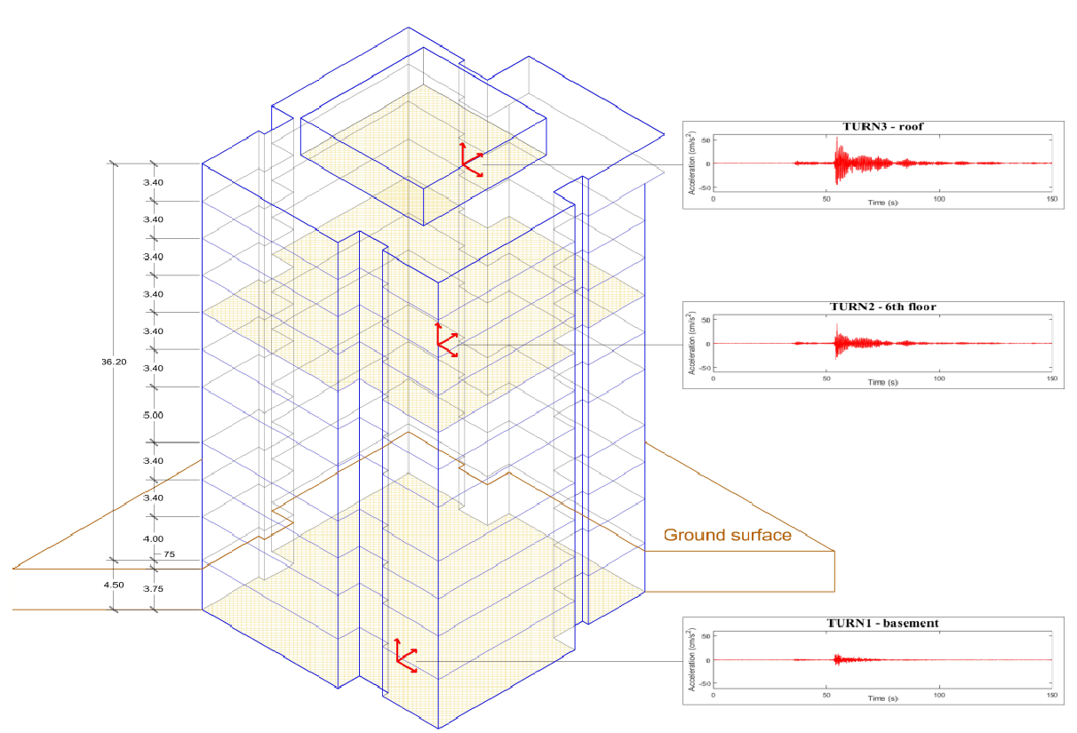

Figure 2. Example of an instrumentation setup and of time-histories recorded during an earthquake.

Another tool that is used to perform seismic monitoring of structures at INFP is the Bighorn module. This module is an extension module of the Antelope package that performs real-time computations of spectral acceleration exceedance and issues alarms accordingly. The idea is to compare the strong motion response spectra to a set of exceedance limit spectra and issue an alarm based on the level of exceedance. The testing of this procedure and a case-study on Bucharest is presented in [14], for the Oct 28th 2018 earthquake. The reporting services are currently performed in an offline environment, but an online platform to be used for rapid analysis is currently under development at the level of INFP.

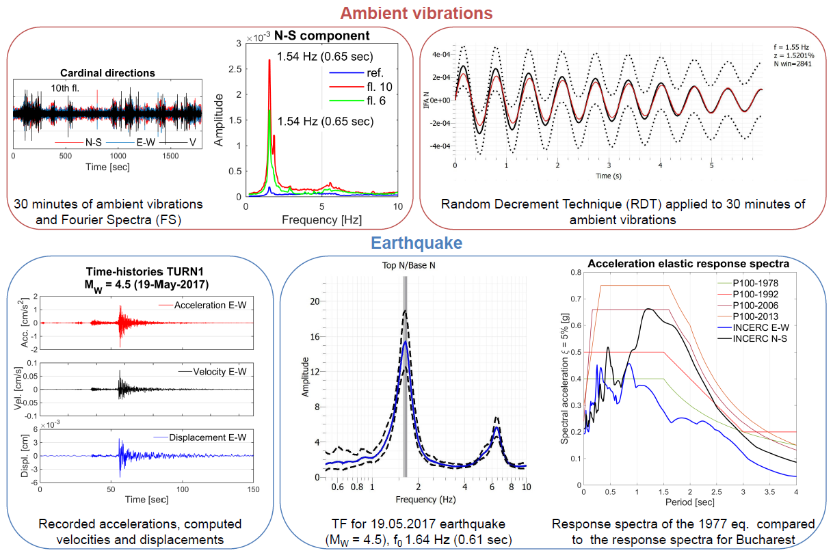

Figure 3. Example of analysis performed on data recorded on structures (ambient vibration and earthquakes).

At URBAN-INCERC, SHM is conducted by using the ARTeMIS Modal Pro software (Fig. 4), which is currently in process of implementation within an experimental project for the real-time damage detection in buildings [15,16]. ARTeMIS Modal performs Operational Modal Analysis, Experimental Modal Analysis and Operating Deflection Shapes analysis, including, in addition, various plug-in modules for SHM. Among these, the Damage Detection module, developed for long-term monitoring, identifies changes in the dynamic behavior of the structure, while allowing it to be set up to ignore influences of ambient conditions on the monitored parameters. Notifications can be sent automatically by sound, e-mail or web services when a specified control value has been exceeded, warning about potential damage in the structure. A Modal Parameter History module and a Drift Analysis Module are in operation as well, for more in-depth analyses of the evolution of structure state and behavior.

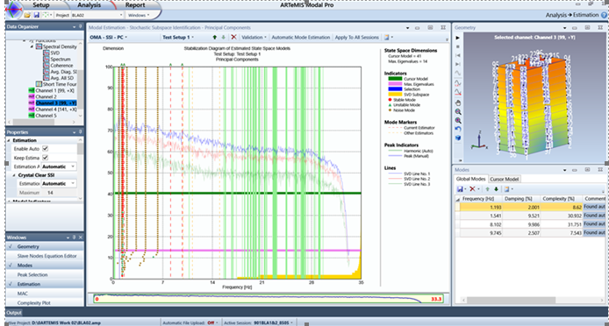

Figure 4. Use of ARTeMIS software at URBAN-INCERC for the structural monitoring of a multi-story building.

# 3. Rapid earthquake loss estimation

For operational purposes, INFP, along with UTCB and NORSAR Institute focused on developing a system capable of automatic and rapid estimation of earthquake losses (entitled Seisdaro), based on ShakeMap and methods for estimating building damage analytically. Seisdaro became operational at INFP in 2011, contributing to the decisional process within Inspectorates for Emergency Situations. The first version of Seisdaro [17] allowed the estimation of building damage and population losses in the Romania - Bulgaria cross-border region, using SELENA software [18]. Since then, Seisdaro has been under continuous development and improvement, providing since version 3 national coverage.

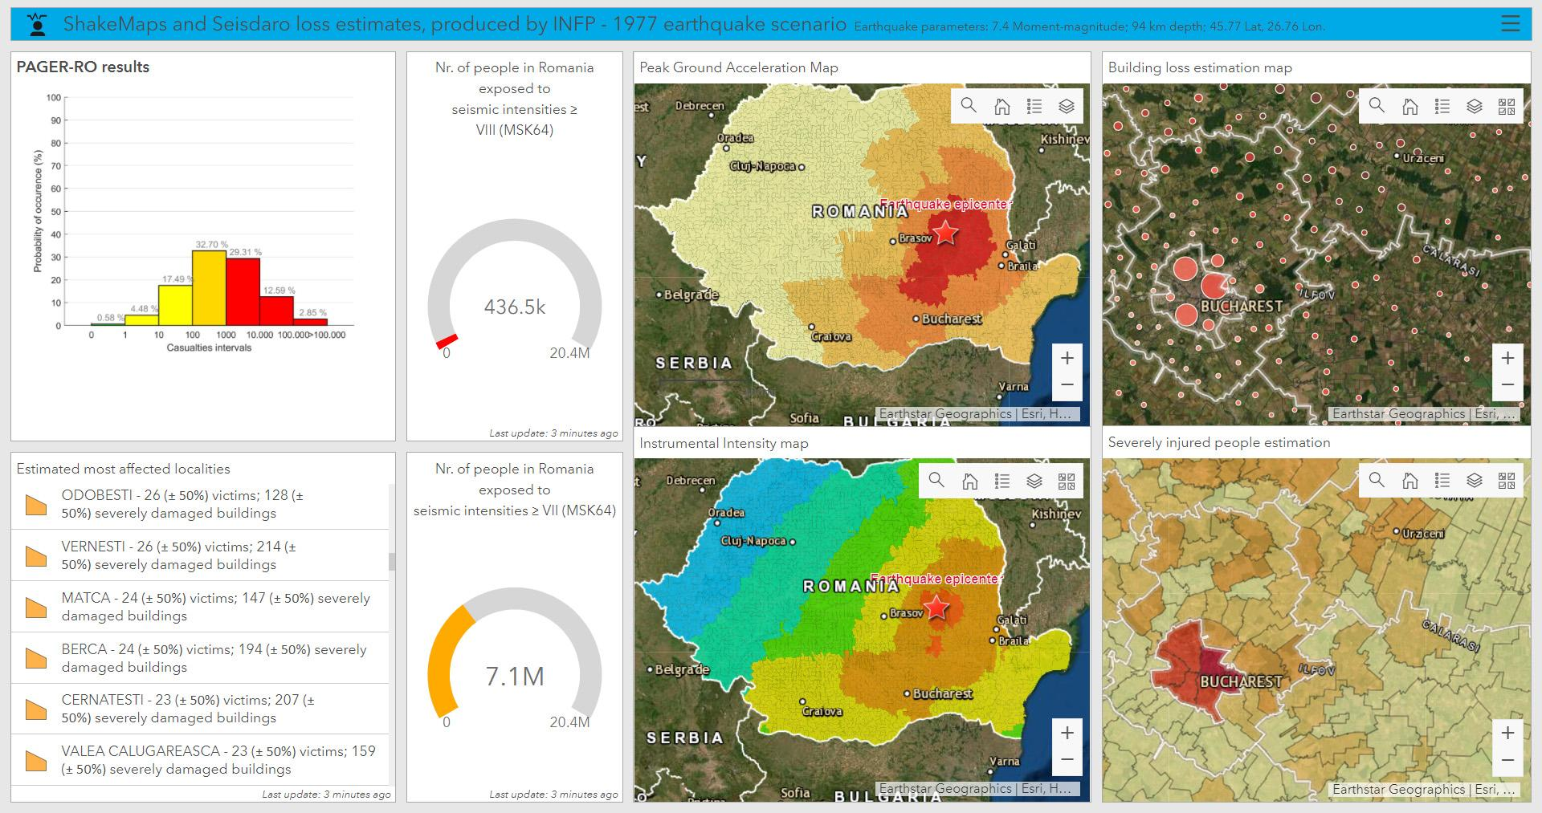

Figure 5. Example of webGIS operational dashboard created for a scenario of the 4 March 1977 earthquake; this is one of the representation forms for ShakeMap and Seisdaro output, for authorities.

Its current version (3) was implemented in 2017 [19] and it allows the rapid estimation of affected buildings and socio-economic losses generated by earthquakes ≥ 3.0 ML in Romania and nearby, using two modules:

* PAGER: using the USGS PAGER methodology [20], customized for Romania;
* SELENA: estimates, at commune/city/sector level, the number of residential buildings damaged (using The Improved Displacement Coefficient Analytical Method) and the number of casualties. The estimation is based on capacity and fragility functions from HAZUS-MH or RISK-UE Project [21], for more than 49 national representative building typologies.

Both modules use input enhanced exposure data from the Romanian Population and Housing Census in 2011, intensity measures and earthquake parameters from the Earthquake Early Warning System (REWS) or ShakeMap systems of INFP, which use data from the Romanian Seismic Network.

Results, in the form of maps, graphs, GIS data and webGIS dashboards (Fig. 5), are generated, after receiving input data from REWS or ShakeMap, in 10-15 seconds (PAGER module) and 2-3 minutes (SELENA module). This means that all results (for both sets of input data) are generated typically in less than 15 minutes after a moderate or major earthquake.

Seisdaro can be used also in earthquake simulation conducted by the authorities in the emergency management field, helping them quantify the needs and improve procedures of intervention. An example was the SEISM 2019 national earthquake exercise. Also, Seisdaro was applied for the analysis of Bucharest at sector level [22] and at census tract level [23].

# 4. Discussion and perspectives

By combining the two methodologies, seismic monitoring of structures and state-of-the-art loss estimation methodologies, a rapid and informed response to earthquake and the mitigation of seismic risk can be achieved. The improvement of the loss estimation methodologies, by taking into account more specific seismic design levels provided by the code, country-specific modern fragility curves, data from more seismic stations and improved ShakeMap methodology relying on new ground motion models and weighting schemes is also a necessity in order to reduce the uncertainty of the loss estimations. A larger number of buildings, representing different typologies (material, structural system, height regime and construction period) should be instrumented. Given that Bucharest is the most endangered city, a customized ShakeMap and a custom loss estimation system, using a new SELENA version, new fragility functions and loss estimation methods will be implemented for this area, within the TURNkey project. For Seisdaro version 4, which is under development, multiple improvements are planned, among which:

* new exposure and vulnerability models compatible also with the European seismic risk model (ESRM) 2020 [24] and with OpenQuake input requirements;
* new ground motion models.
* integration of the P100-1/2013 response spectra and of a 8 values spectral acceleration spectrum for real-time computations, as included in SELENA version 6.5;

Given the influence of the atmospheric condition on the dynamic parameters of structures, as observed in previous studies [25, 26], a case-study building will be instrumented with both seismic sensors and a meteorological station, in the framework of the PREVENT project. The aim is to observe the influence of the atmospheric condition on the dynamic parameters of structures. Moreover, by using both low-cost and professional sensors, a complex structural identification will be possible.

In conjunction with the advances in research, a critical aspect is to update and to align the official technical codes and guidelines to the latest international practice. The development of a national guideline regarding the SHM will be necessary, with clear requirements regarding the instrumentation, installation procedures, acquisition, processing and reporting. Recently, a number of private companies have started using commercial softwares to perform seismic monitoring of structures. An effort should be made to facilitate the data access and harmonize the processing tools, so that after an earthquake to be able to evaluate how different types of structures respond to the seismic movement and what are the expected damage states.

# 5. Conclusions

The efforts done in the last years regarding the large-scale use of SHM and rapid loss estimation methods were merely individual initiatives, lacking a close communication and collaboration between public authorities and private entities. However, this situation has to be overpassed and much greater and consistent coordinated efforts should strengthen and enhance the outcomes of these activities, in order to add value to the current status. Given the tectonic setting of the Vrancea region and the intermediate-depth earthquakes characteristics, more country-specific studies need to be performed. In addition, the frequency content of the ground motion, specific for Bucharest in case of large Vrancea earthquakes, and its effect on different building typologies, needs further investigations. As stated in the previous sections, the economic benefits of such a system were already proven efficient in other countries, so the use of this modern tool should be better exploited in Romania, in the near future, to prepare for potential destructive earthquakes that could hit the country.

# 6. Acknowledgements

Part of this has been carried out within the TURNkey (Towards more Earthquake-resilient Urban Societies through a Multi-sensor-based Information System enabling Earthquake Forecasting, Early Warning and Rapid Response actions) project (GA 821046), funded by the European Union’s Horizon 2020 research and innovation programme, PREVENT (Open system for integrated civil structures monitoring) and PRE-QUAKE projects, supported by a grant of funding provided to INFP by the Romanian Ministry of Research, and Innovation and Digitalization, CCCDI – UEFISCDI, project no. PN-III PNIII-P2-2.1-PED-2019-0832. and PN-III-P1-1.1-PD-2019-0969. Recent research on seismic instrumentation and SHM has and is being conducted at URBAN-INCERC within the “Nucleu'' Programme, projects CONCRET (PN 18-35 01 01) and ECOSMARTCONS (PN 19-33 01 01), funded by the Romanian Ministry of Education and Research, whose financial support is gratefully acknowledged.

# 7. Copyrights

1CroCEE 2021 reserves the copyright on the published proceedings. Authors will have the right to use the content of published papers, in part or in full, for their own work. Authors who use previously published data and illustrations must acknowledge the original source in the accompanying captions.

# 8. References

1. Balan St., Cristescu V., Cornea I. (coordinators) (1982): *The Romanian Earthquake of 4th of March 1977*, Romanian Academy Publishing House, Bucharest, Romania. (in Romanian)
2. Šavor Novak, M., Uroš, M., Atalić, J., Herak, M., Demšić, M., Baniček, M., Lazarević, D., Bijelić, N., Crnogorac, M., Todorić, M. (2020): Zagreb earthquake of 22 March 2020 – preliminary report on seismologic aspects and damage to buildings, *GRAĐEVINAR*, **72** (10), 843-867, doi: <https://doi.org/10.14256/JCE.2966.2020>
3. Federation internationale du beton - fib (2003): Monitoring and safety evaluation of existing concrete structures, *State-of-the-art report.*
4. Georgescu, E. S., Borcia, I. S., Praun, I. C., Dragomir, C. S. (2010): State of the art of structural health monitoring in seismic zones of Romania, *Proceedings of MEMSCON Workshop Structural Monitoring and Status-Dependent Maintenance and Repair of Constructed Facilities*, Bucharest, Romania.
5. P100-1/2006 (2006): Seismic design code - part I: Design prescriptions for buildings, MTCT, Romania.
6. P100-1/2013 (2013): Seismic design code - part I: Design prescriptions for buildings, MDRAP, Romania.
7. Aldea, A., Kashima, T., Lungu, D., Vacareanu, R., Koyama, S., Arion, C. (2004): Modern urban seismic network in Bucharest, Romania, *First International Conference on Urban Earthquake Engineering*, Yokohama, Japan, 8 pages.
8. Demetriu, S., Aldea, A. (2006): Recorded seismic response of an instrumented high-rise reinforced-concrete building in Bucharest, *First European Conference on Earthquake Engineering and Seismology*, Geneva, Switzerland, 10 pages.
9. Aldea, A., Iiba, M., Demetriu, S., Kashima, T. (2007): Evidence of soil-structure interaction from earthquake records at a high-rise building site in Bucharest, *4th International Conference on Earthquake Geotechnical Engineering*, Thessaloniki, Greece, 12 pages.
10. Perrault, M., Gueguen, P., Aldea, A., Demetriu, S. (2013): Using experimental data to reduce the single-building sigma of fragility curves: case study of the BRD tower in Bucharest, Romania, *Earthquake Engineering and Engineering Vibration*, **12** (4), 643-658, <https://doi.org/10.1007/s11803-013-0203-z>
11. Demetriu, S., Aldea, A., Udrea, A. (2012): Modal parameters of a RC frame structure identified from ambient vibration measurements, *15th World Conference on Earthquake Engineering*, Lisbon, Portugal, 10 pages.
12. Tiganescu, A., Grecu, B., Craifaleanu, I. G. (2020): Dynamic Identification for Representative Building Typologies: Three Case Studies from Bucharest Area, Civil Engineering Journal, 6 (3), 418-430, doi: <http://dx.doi.org/10.28991/cej-2020-03091480>
13. Tiganescu, A., Balan, E. S. F., Toma-Danila, D., Apostol, B. F. (2019): Preliminary analysis of data recorded on instrumented buildings from Bucharest area during the 28th October 2018 Vrancea earthquake, *19th International Multidisciplinary Scientific GeoConference*, Albena, Bulgaria, 8 pages.
14. Balan, S. F., Tiganescu, A., Apostol, B. F., Danet, A. (2019). Post-earthquake warning for Vrancea seismic source based on code spectral acceleration exceedance, *Earthquakes and Structures*, **17** (4), 365-372, doi: <https://doi.org/10.12989/eas.2019.17.4.365>
15. Dragomir, C. S., Craifaleanu I. G., Dobre, D., Georgescu, E. S. (2019): Prospective studies for the implementation of a remote access earthquake damage detection system for high-Rise buildings in Romania*, IOP. Conference Series Earth and Environmental Science* 221, no. 012036.
16. Dragomir, C. S., Dobre, D., Craifaleanu I. G., Georgescu, E. S. (2020): An integrated national system for assuring the quick evaluation of the vulnerability of all instrumented buildings after an earthquake. Recent developments, Scientific Papers. Series E. Land Reclamation, Earth Observation & Surveying, Environmental Engineering, IX, 94–97.
17. Erduran, E., Lang, D.H., Lindholm, C., Toma-Danila, D., Balan, S.F., Ionescu, V., Aldea, A., Vacareanu, R., Neagu, C. (2012): Real time earthquake damage assessment in Romanian-Bulgarian Border, *15th World Conference on Earthquake Engineering*, Lisbon, Portugal.
18. Molina, S., Lang, D. H., Lindholm, C. D. (2010): SELENA—An open-source tool for seismic risk and loss assessment using a logic tree computation procedure, *Computers & Geosciences,* **36**, no. 3, 257–269, doi: <https://doi.org/10.1016/j.cageo.2009.07.006>
19. Toma-Danila, D., Cioflan, C., Ionescu, C., Tiganescu, A. (2018): The near real-time system for estimating the seismic damage in Romania (SeisDaRo)—Recent upgrades and results, *16th European Conference on Earthquake Engineering*, Thessaloniki, Greece.
20. Jaiswal, K., Wald, D. J., Hearne, M. (2009): *Estimating casualties for large earthquakes Worldwide using an empirical approach*, U.S. Geol. Surv Open-File Rept. 2009-1136.
21. Milutinovic, Z. V., Trendafiloski, G. S. (2003): WP4 of RISK-UE project (An advanced approach to earthquake risk scenarios with applications to different European towns), Vulnerability of Current Buildings, grant agreement ID: EVK4-CT-2000-00014.
22. Toma-Danila, D., Zulfikar, C., Manea, E. F., Cioflan, C. O. (2015): Improved seismic risk estimation for Bucharest, based on multiple hazard scenarios and analytical methods, *Soil Dynamics and Earthquake Engineering*, **73**, 1-16, doi: <https://doi.org/10.1016/j.soildyn.2015.02.013>
23. Toma-Danila, D., Armaş, I. (2017): Insights into the possible seismic damage of residential buildings in Bucharest, Romania, at neighborhood resolution, *Bulletin of earthquake engineering*, **15** (3), 1161-1184, doi: <https://doi.org/10.1007/s10518-016-9997-1>
24. Crowley, H., Despotaki, V., Rodrigues, D., Silva, V., Toma-Danila, D., Riga, E., ... & Gamba, P. (2020): Exposure model for European seismic risk assessment, *Earthquake Spectra*, **36**(1_suppl), 252-273, doi: <https://doi.org/10.1177/8755293020919429>
25. Herak, M., Herak, D. (2010): Continuous monitoring of dynamic parameters of the DGFSM building (Zagreb, Croatia), *Bulletin of Earthquake Engineering*, **8**, 657–669. <https://doi.org/10.1007/s10518-009-9112-y>
26. Guéguen, P., Tiganescu, A. (2018): Consideration of the effects of air temperature on structural health monitoring through traffic light-based decision-making tools, *Shock and Vibration*, 2018, doi: <https://doi.org/10.1155/2018/9258675>